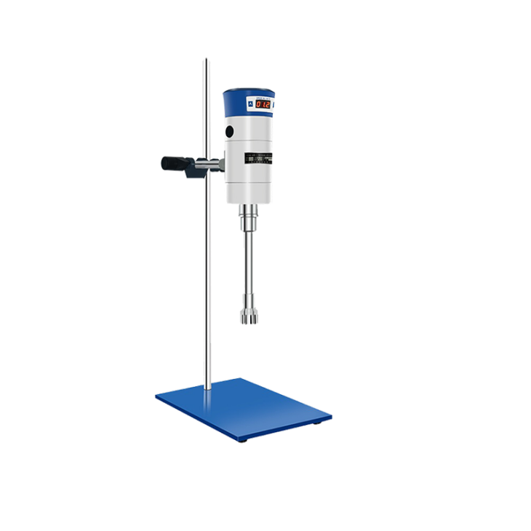

# **FJ300-SH Digital high speed dispersing homogenizer**

**Application：**

● The laboratory high-speed dispersion homogenizer is driven by a compact series-excited miniature high-speed motor, which is suitable for the laboratory to further disperse and homogenize the crushed experimental materials in the liquid medium. The machine is composed of a high-density die-casting aluminum alloy as the main engine of the body, a dispersed and homogeneous working head made of high-quality stainless steel and a speed-adjusting base. It has the characteristics of high host drive speed, high output power, convenient work head loading and unloading, and simple experimental operation.

**Main Features：**

● The drive motor use a series-excited micro motor with high output power and compact structure, and the design is safe and reliable;

● All parts of the working head contacting materials are made of high-quality stainless steel with good corrosion resistance;

● The working head is connected with the drive motor by a coupling, which is easy to disassemble and assemble;

● Speed governor base adopts stepless controller, convenient speed control and stable operation.

**Techncial Parameters：**

|  |  |
| --- | --- |
| Model | FJ300-SH |
| Range of rotation | 300-18000r/min |
| Processing capacity | 100-13000ml |
| Input power | 510W |
| Output Power | 300W |
| Dimensions | 250x350x600mm |
| Using electric | AC 220 V 50 Hz |
| Rated torque | 68N.cm |
| Working head configuration | φ28mm， φ36mm |
| Work method | Intermittent |
| Output Power | 300W |

**Working head configuration：**

|  |  |  |  |  |
| --- | --- | --- | --- | --- |
| Working head specifications | 12G | 18G | 28G | 36G |
| Processing capacity (ml) | 30-800 | 50-1500 | 100-8000 | 150-13000 |
| Suitable viscosity mpa.s | 35/110 | 45/150 | 60/155 | 60/160 |
| Stator diameter(mm) | 12 | 18 | 28 | 36 |
| Length of working head(mm) | 170 | 210 | 235 | 270 |
| Operating temperature(℃) | 120 | 120 | 120 | 120 |
| Work head material | SS304 | SS304 | SS304 | SS304 |
| Bearing material | PTFE | PTFE | PTFE | PTFE |