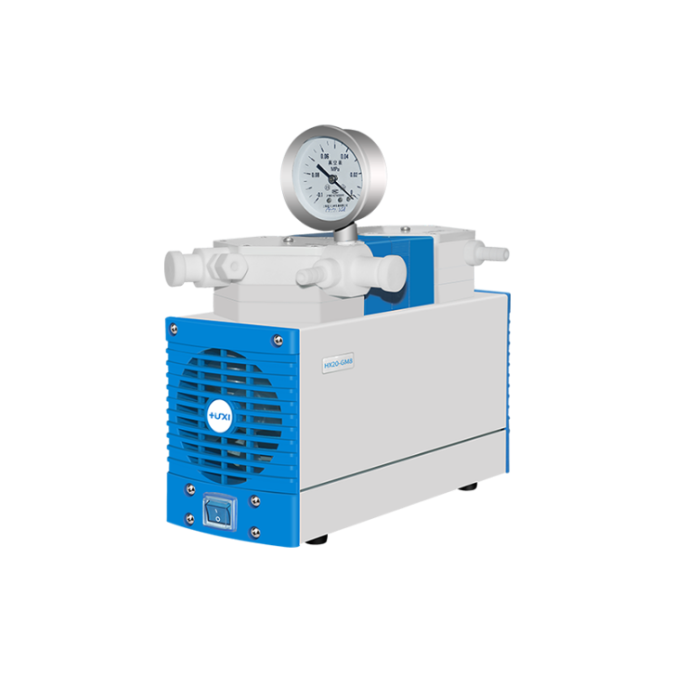

# **HB-40B Corrosion Resistant Diaphragm Pump**

**Application：**

● The corrosion-resistant vacuum diaphragm pump is a two-stage pump with a gas medium. All parts in contact with the gas are made of polytetrafluoroethylene (PTFE) material, which has a high degree of corrosion resistance and a wide range of applications. It can completely replace the water circulation pump and is suitable for chemical , Pharmaceutical, petrochemical and other industries for the treatment of corrosive gases, such as oil filtration, vacuum distillation, rotary evaporation, vacuum concentration, centrifugal concentration, solid extraction, etc.

**Main Features：**

● Resist strong chemical corrosion

The corrosion-resistant vacuum pump uses a special diaphragm (the surface of the diaphragm is compounded with PTFE coating) and pump head design, including all joints and pipelines, to ensure that the parts in contact with the gas are imported PTFE materials, so it can withstand most corrosive At the same time, electrical switches and casings are also treated with anti-corrosion treatment, especially the transmission mechanism and circuit parts are made of corrosion-resistant materials to form a closed space, which is completely isolated from the external environment, so that the vacuum pump is not only resistant to corrosive media, but also perfectly suitable for corrosion. In a sexual environment, the problem of chemical corrosion resistance of the vacuum pump is completely solved;

● No pollution and maintenance free

The diaphragm vacuum pump can realize the complete recovery of the solvent, eliminate the pollution of toxic and harmful organic solvents to the environment and the harm to the health of operators and nearby personnel, even if the mixed solvent can be highly recycled; the diaphragm pump is a dry pump without water and oil , Make the laboratory clean and quiet, users do not need to regularly clean, change pipes, water and other maintenance work, the diaphragm vacuum pump is 100% maintenance-free;

● Low noise, low vibration

The corrosion-resistant vacuum pump adopts electric motor direct drive power transmission without intermediate transmission parts, coupled with the characteristics of low stroke and low noise of the diaphragm, so the noise of the product can be kept below 70dB;

● Overheating protection

Each product is equipped with a temperature protection switch, which will automatically stop when the internal temperature of the body is too high, and then start automatically after the temperature cools down to ensure the stability and safety of the system;

**Techncial Parameters：**

|  |  |
| --- | --- |
| Model | HB-40B |
| Rated voltage/frequency | 220V/50Hz |
| Rated power | 240W |
| Pump head type | Two-stage pump |
| Ultimate vacuum | 6-8mbar |
| Operating pressure | 1bar |
| Maximum flow | 40L/min |
| Interface specifications | 10mm |
| Medium and ambient temperature | 5~40℃ |
| Relative humidity | ＜80% |
| Pump head material | PTFE |
| Composite diaphragm material | HNBR+PTFE (non-standard products can be customized according to customer requirements) |
| Valve material | FKM, FFPM (non-standard products can be customized according to customer requirements) |
| Vacuum gauge | With vacuum regulator |
| Work system | Continuously working |
| Noise | ＜ 55db |
| Rated speed | 1450 rpm |
| Dimensions | （L*W*H）:320*170*270 |
| Weight | 11kg |