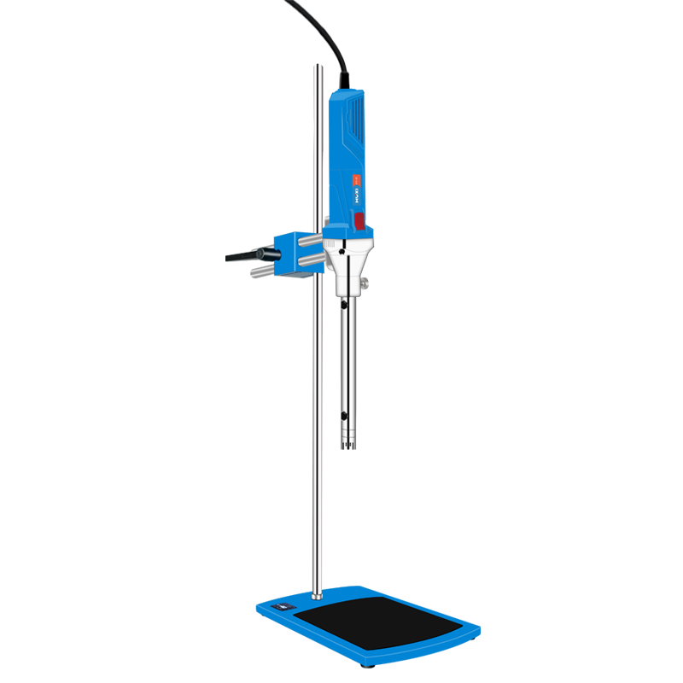

# **HR-25 Laboratory Homogenizer**

**Application：**

● HR-25 laboratory homogeneous emulsifier is a mechanical equipment specially designed for sample homogeneous emulsification. It can be equipped with a variety of working heads of different specifications to quickly realize sample dispersion, homogenization, emulsification, suspension, stirring, etc. At present, it has been widely used in biological animal and plant tissue cells, medicine, cosmetics, food, medicine, chemical industry and many other fields.

**Main Features：**

●A variety of working heads of different specifications to meet the processing capacity of 0.2~10000ml;

● 0~999min timing range, the instrument stops automatically after the operation is over;

● With 1~6 gears, the speed can be adjusted, which is suitable for different sample processing requirements;

● With LCD digital display function, the speed, time and sample temperature are clear to show;

● High-performance brushless motor, strong and efficient, stable operation, low noise, long life, can run for a long time;

● Stepless speed regulation function, the max speed can reach 30000rpm, providing a linear speed of 27m/s for sample homogenization;

● Two-way support rod design combined with double-hole fixing clips to form an integrated lifting adjustment system to make your experiments more reliable and safer;

● The digital display model can be equipped with a temperature sensor to measure the temperature of the sample in real time. When it reaches the set value, it will automatically stop running, making the experiment safe and secure.

**Techncial Parameters：**

|  |  |
| --- | --- |
| Model | HR-25 |
| Item No | 1004023000 |
| Type | Basic |
| Rated Voltage (V) | 200-240(optional 110V) |
| Frequency | 50-60HZ |
| Rated Input Power | 1500W |
| Rated Output Power | 1250W |
| Max Input Power | 2300w |
| Max Output Power | 1700w |
| Motor type | DC Brushless motor |
| Speed range | 7500-30000rpm |
| Speed control | gear |
| Capacity | 0.2-10000ml |
| Set Standard | Machine+working head+stand |
| Standard working head | HR25 25g-S2V |
| Machine Size | 410*90mm |
| Machine packing Size | 470*340*205mm |
| Machine NW | 2.6KG |
| Machine GW | 3KG |
| Set NW | 7KG |
| Set GW | 8KG |