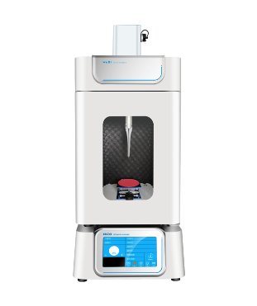

# **HX-1200 Intelligent ultrasonic homogenizer**

**Application：**

* It is suitable for the processing of different volumes of samples (according to different volumes of the corresponding models and probes). It can be used for emulsification, separation, dispersion, extraction, cleaning and acceleration of chemical reactions, etc. It is widely used in life science, material science and environmental protection.

**Main Features：**

●  High safety

    With over-temperature, overload and time alarm functions;  
● Process visualization

    External transparent front door;  
● Space saving

   Top and bottom stacking design, save lab space;  
● Flexible parameters

    The length of the experiment, power can be continuously adjusted, has good stability;

● Wide range of processing

   Different models of instruments can be applied to different customers' needs.

**Techncial Parameters：**

|  |  |
| --- | --- |
| Model | HX-1200 |
| Power | 12-1200W continuously adjustable |
| Processable capacity | 1-1000 |
| Display method | Color 7-inch touch capacitice screen with high definition display |
| Single working time | 0.1-99.9S |
| Single work gap time | 0.1-99.9S |
| Total time (ultrasound + gap) | 1-99H59M59S |
| Frequency range | 20-25KHz |
| Temperature control range | 0-100℃（Optional low temperature, constant temperature） |
| Alarm function | Temperature, time, overload, no load, over temperature |
| Standard variable width rod | Φ20(mm) |
| Optional variable width rod | Φ3、6、8、10、15、22、25(mm) |
| Data Storage | 20groups |
| Power supply | 220V/110V/ 50Hz/60HZ |
| Ultrasonic mainframe size(D*W*H) | 427*340*168（mm） |
| Ultrasonic mainframe net weight | 15kg |
| Ultrasonic transducer+Variable width rod net weight | 2.5kg |
| Ultrasonic mainframe outer packaging(D*W*H) | 500*400*320（mm） |
| Sound isolating box outer packaging(D*W*H） | 385*385*585（mm） |
| Sound isolating box net weight | 13kg |
| Sound isolating box size(D*W*H) | 320*320*520（mm） |
| Control method | Microcontroller+TFT touch |
| Up and down stacking function(can save space) | Support |
| Working voice alarm and fault indication function | Support |
| Ultrasonic power simulation data waveform display function | Support |
| Ultrasonic time pulse width data waveform display function | Support |
| Password protection function | Support |
| Ultrasonic mainframe material | Aluminum alloy+ABS plastic (Disposable molding molds) |
| Sound isolating box material | Anti-corrosion panels+ABS plastic(Disposable molding molds) |