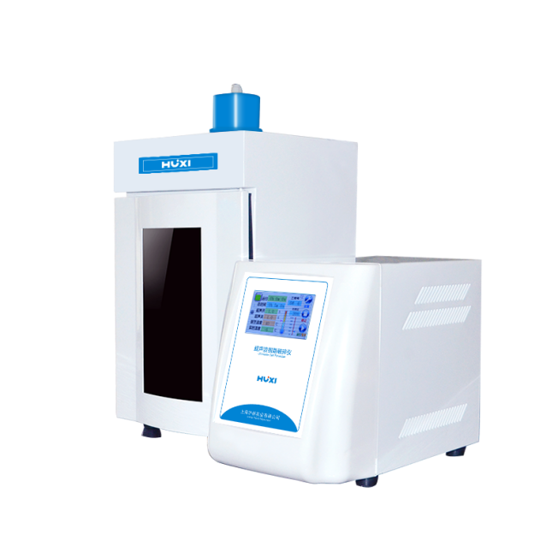

# **HX-IID Ultrasonic Homogenizer**

**Application：**

* Ultrasonic Ultrasonic Homogenizer is a multi-functional and multi-purpose instrument that uses strong ultrasound to produce cavitation effect in liquid and ultrasonically treat substances. It can be used for a variety of animal and plant cells and viruses. Cell disruption can also be used for emulsification, separation, extraction, defoaming, degassing, cleaning and accelerating chemical reactions, etc. It is used in the teaching, research and production of biochemistry, microbiology, medicinal chemistry, surface chemistry, physics, zoology, agronomy, pharmacy and other fields.

**Main Features：**

* Full-featured, beautiful appearance, reliable performance, using the latest single-chip technology + 4.3-inch TFT capacitive touch screen control (7-inch optional), optional computer communication or data printing functions.
* High degree of intelligence, centralized control by the central computer, ultrasonic time and power can be set from 1%-100%.
* Sample temperature detection and display, frequency microcomputer automatic tracking, automatic fault alarm.
* One set of soundproof box, reducing noise by more than 70%.
* Supporting Alcoa 7075 transducer + a set of high-purity titanium alloy horns, industrial horns can continuously achieve ultrasound for more than one hour (only high-purity titanium alloys can be achieved)
* With overload protection function and the horn is not immersed in liquid, it will automatically protect the horn from damage.
* It can realize the voice alarm function caused by malfunction, over-temperature or operation error, which is more humane.

**Techncial Parameters：**

|  |  |
| --- | --- |
| Model | HX-IID |
| Power | 10-1000WContinuously adjustable |
| Crushing capacity | 0.1-750ML(Need to choose the corresponding horn) |
| Display method | True color capacitive touch screen display |
| Single ultrasound time | 0.1-99.9S |
| Single gap time | 0.1-99.9S |
| Total time (ultrasound + gap) | 1-99H59M59S |
| Frequency Range | 20-25KHz |
| Temperature control range | 0-100 degrees (optional low temperature and constant temperature) |
| Alarm function | Temperature, time, overload, no load, over temperature |
| Optional horn | Φ2、3、8、10、12、15(mm) |
| Duty cycle | 0.1-99.9% |
| Data storage | 20 groups |
| Power supply (optional 110V) | 220V/110V/ 50Hz/60Hz |
| Net size of the instrument (D*W*H) | 410*225*290（mm） |
| Ultrasonic host net weight | 12kg |
| Ultrasonic host gross weight | 16kg |
| Host packaging (length * width * height) | 470*305*430（mm） |
| Gross weight of soundproof box | 10kg |
| Outer packing of soundproof box (length * width * height) | 350*350*550（mm） |
| way to control | MCU + TFT touch |
| Optional function | Computer communication + data printing + soundproof box lighting or sterilization |
| Voice alarm and prompt function | Yes |