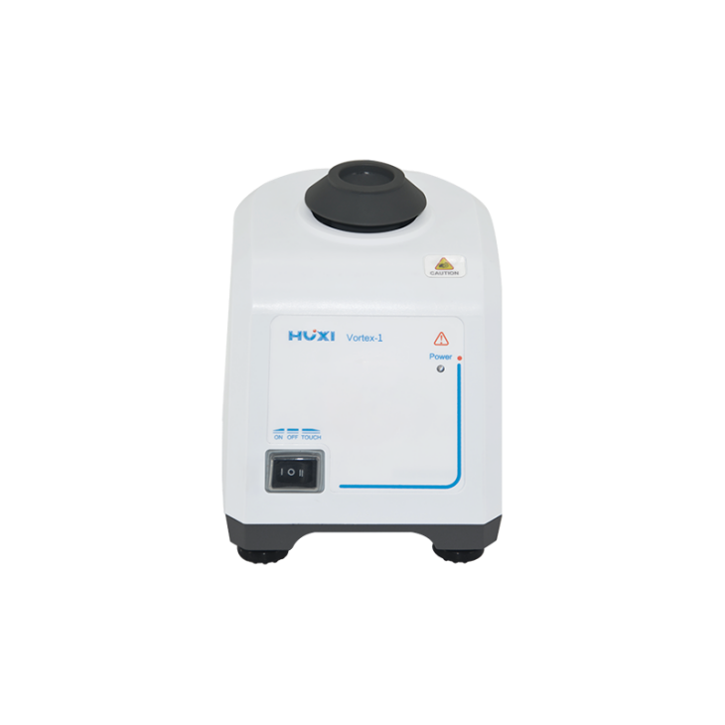

# **Vortex-1 Vortex Mixer**

**Application：**

●The new digital display model of the vortex mixer is driven by a DC motor and has an eccentric structure design. It can mix and oscillate the liquid in the container. It is widely used in biochemistry, genetic engineering, medicine and other experimental fields.

**Main Features：**

● Fixed speed 2800RPM.

● Eccentric ball shaft design, the shaking head is easy to install.

● Soft silicone foot pads prevent the instrument from moving when it vibrates at high speed. It is compact and shockproof, suitable for high-speed work.

● Small size, low power consumption and low noise.

● The body use reinforced engineering plastic molding technology, and the body has no paint spraying, acid and alkali resistance and collision resistance.

● All work surfaces are made of corrosion-resistant, wear-resistant, and safe TPU materials, which change the easily damaged characteristics of the original sponge surface.

● The instrument integrates the functions of continuous, point vibration, continuous, speed regulation, etc., which provides a fast operation platform for the experiment.

**Techncial Parameters：**

|  |  |
| --- | --- |
| Model | Vortex-1 |
| Voltage | 200~230V/100~120V（optional） |
| Frequency | 50Hz，60Hz |
| Power | 60w |
| Shaking mode | Orbital |
| Shaking diameter | 4mm |
| Motor Type | Shaded Pole Motor |
| Motor input power | 60w |
| Motor output power | 11w |
| Speed range | 2800rpm |
| Speed Display | / |
| Operation mode | Touch/Continuous |
| Exterior Dimension | 165x130x140（mm） |
| NW | 2.0kg |
| Allowable ambient temperature | 5-40℃ |
| Allowable ambient humidity | 80% |
| Shell Protection class | IP21 |
| Standard | Wear-resistant standard head |
| Base material | Aluminum alloy |