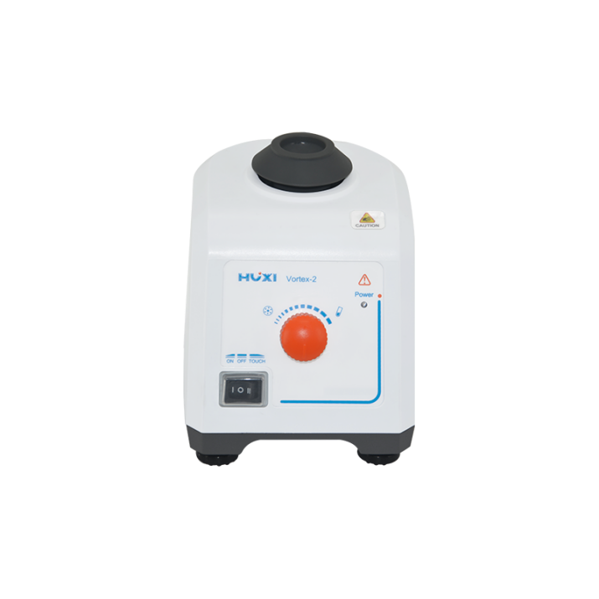

# **Vortex-2 Vortex Mixer**

**Application：**

●The vortex mixer is simple and reliable structure, small size, low power consumption, low noise, etc. It is widely used in biochemistry, genetic engineering, medicine and other experimental needs. For liquid-liquid, liquid-solid, solid-solid (powder) mixing, it can quickly mix any liquid or powder that needs to be mixed with a high-speed vortex type, and the mixing speed is fast, uniform and thorough.

**Main Features：**

● Stepless speed regulation, up to 2800 RPM.

● Eccentric ball shaft design, the shaking head is easy to install.

● Soft silicone foot pads prevent the instrument from moving when it vibrates at high speed. It is compact and shockproof, suitable for high-speed work.

● Small size, low power consumption and low noise.

● The body use reinforced engineering plastic molding technology, and the body has no paint spraying, acid and alkali resistance and collision resistance.

● All work surfaces are made of corrosion-resistant, wear-resistant, and safe TPU materials, which change the easily damaged characteristics of the original sponge surface.

● The instrument integrates the functions of continuous, point vibration, continuous, speed regulation, etc., which provides a fast operation platform for the experiment.

**Techncial Parameters：**

|  |  |
| --- | --- |
| Model | Vortex-2 |
| Voltage | 200~230V/100~120V（optional） |
| Frequency | 50Hz，60Hz |
| Power | 60w |
| Speed control mode | knob |
| Shaking mode | Orbital |
| Shaking diameter | 4mm |
| Motor Type | Shaded Pole Motor |
| Motor input power | 60w |
| Motor output power | 11w |
| Speed range | 0~2800rpm |
| Speed Display | Graduate |
| Operation mode | Touch/Continuous |
| Exterior Dimension | 165x130x140（mm） |
| NW | 3.6kfg |
| Allowable ambient temperature | 5-40℃ |
| Allowable ambient humidity | 80% |
| Shell Protection class | IP21 |
| Standard | Wear-resistant standard head |
| Base material | Aluminum alloy |