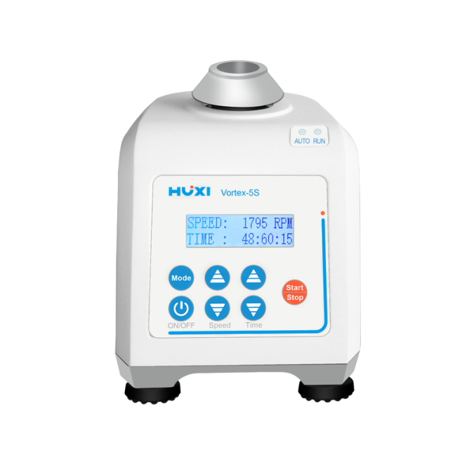

# **Vortex-5S Vortex Mixer**

**Application：**

●The new digital display model of the vortex mixer is driven by a DC motor and has an eccentric structure design. It can mix and oscillate the liquid in the container. It is widely used in biochemistry, genetic engineering, medicine and other experimental fields.

**Main Features：**

● 100 ~ 240V wide voltage design, a wide range of applications;.

● Operation mode: light sensing/continuous two modes are available;

● The permanent magnet DC motor is not easy to heat up, with a long service life, and can run for a long time;

● 1~99h59m59s timing function, it will stop automatically when the time comes, easy to operate;

● Soft silicone foot pads, super shockproof, stable body when working at high speed;

● Various specifications of adapters are available to meet different experimental needs.

**Techncial Parameters：**

|  |  |
| --- | --- |
| Model | Vortex-5S |
| Voltage | 100~240V |
| Frequency | 50~60Hz |
| Motor Type | DC motor |
| Speed Range | 180~2800rpm |
| Adjust mode | Press button |
| Operation mode | Touch (light sensing)/continuous |
| Shaking mode | Orbital |
| Base Material | Zinc alloy |
| Orbital diameter(mm） | 4 |
| Input Power(W) | 60 |
| Ambient temperature(℃) | 5~40 |
| Environment humidity(%) | 80 |
| Instrument dimension(mm) | 165*130*140 |
| Packing dimension(mm) | 250*220*190 |
| Instrument NW(kg) | 3 |
| Instrument GW(kg) | 3.5 |