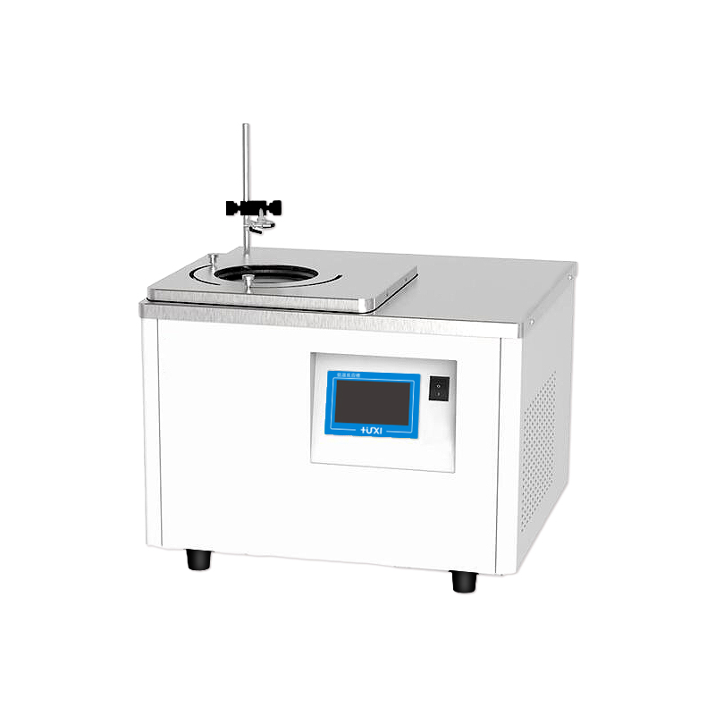

HLM-2005 Magnetic stirring high and low temperature reaction bath

1、Application
HLM series magnetic stirring low-temperature reaction tank can be realized by low-temperature constant temperature or high-temperature constant temperature of the sample directly magnetic stirring, without the need for external installation of electric mixer for sample stirring, easy to use and safe. It is suitable for temperature control in chemical synthesis, testing of electronic components at different temperatures, and material testing.
2、Features
● The reaction tank with low temperature -20℃ adopts double-stage compressor compound stack refrigeration technology, which is powerful refrigeration and reaches the target temperature faster;
● The use of PID temperature control with advanced proportional refrigeration control technology greatly improves temperature stability;
● The magnetic stirrer inside the vessel is rotating, which can maintain the sample temperature uniformity and good precision for a long time;
● DC brushless motor with long life, trouble-free and infinitely adjustable speed;
● Alarm light and sound reminder at the same time, various alarm codes are displayed to determine the cause of the failure and repair methods;
● A variety of operating modes can be selected, accidental power failure can be automatically restored.
- Technical Parameters
Product Model | HLM-2005
Product No. | 1032019001
Tank volume (L) | 5
Temperature range (℃) | -20~40
Temperature stability (℃) | ±0.5
Operating temperature (℃) | 5~32
Speed range (RPM) | 100-1200
Speed regulation mode | Touch screen
Power supply voltage (V) | 200~230
Display temperature mode | LED
Setting mode | Touch Screen
Safety Protection | High temperature protection ,Over temperature protection
Heating power (W) | 750
Cooling power(W) | 300
Refrigeration capacity(W) | 500
Refrigerant | R404A
Stirring sub size(MM) | φ8*30
Sink opening(MM) | φ210
Bath size(MM) | Φ210*150
Maximum capacity of reaction vessel | 1000mL  φ175
Overall dimensions(MM)(W*D*H) | 600*400*500
Outer box size (MM) | 670*470*545
Net weight (KG) | 40
Gross weight (KG) | 44

5、Packing List
Name | Qty
Main unit | 1 piece
Retractable tank cover | 1 piece
Magnetic stirrer | 1 piece
Vessel Clamp Column | 1 piece
Vessel clamp | 1 piece
Vessel clamp holder | 1 piece
Instruction manual | 1 piece

