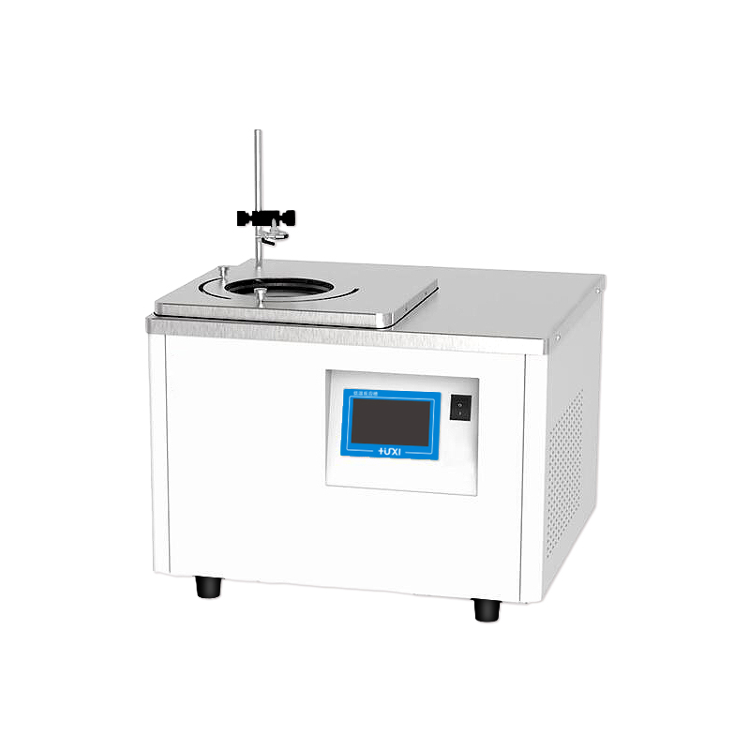

HLM-2005W Magnetic stirring high and low temperature thermostat

bath

1、Application

HLM series magnetic stirring low-temperature reaction tank can be realized by low-temperature constant temperature or high-temperature constant temperature of the sample directly magnetic stirring, without the need for external installation of electric mixer for sample stirring, easy to use and safe. It is suitable for temperature control in chemical synthesis, testing of electronic components at different temperatures, and material testing.

2、Features
● The reaction tank with low temperature -20℃ adopts double-stage compressor compound stack refrigeration technology, which is powerful refrigeration and reaches the target temperature faster;
● The use of PID temperature control with advanced proportional refrigeration control technology greatly improves temperature stability;
● The magnetic stirrer inside the vessel is rotating, which can maintain the sample temperature uniformity and good precision for a long time;
● DC brushless motor with long life, trouble-free and infinitely adjustable speed;
● Alarm light and sound reminder at the same time, various alarm codes are displayed to determine the cause of the failure and repair methods;
● A variety of operating modes can be selected, accidental power failure can be automatically restored.
3、Technical Parameters
Product Model | HLM-2005W
Product No. | 1032035001
Tank volume (L) | 5
Temperature range (℃) | -20~100
Temperature stability (K) | ±0.5
Display precision (℃) | 0.01
Use of ambient temperature (℃) | 5~32
Speed range (RPM) | 100~1200
Speed regulation mode | Knob
Power supply voltage (V) | 200~230V AC/50Hz
Display temperature mode | TFT
Setting mode | Touch Screen
Safety Protection | High Temperature Protection Over Temperature Protection
Heating power (W) | 750
Cooling power(W) | 500
Refrigeration capacity(W) | 500
Refrigerant | R404A
Stirring sub size(MM) | φ8*30
Sink opening(MM) | Φ210
Maximum diameter of reaction vessel (MM) | Φ175
Maximum capacity of reaction vessel (ML) | 1000
Overall dimensions (MM)(W*D*H) | 500*450*370
Packing size(MM)(W*D*H) | 615*565*500
Net weight kg | 38
Gross weight kg | 42

4、Packing List
Name | Qty
Main unit | 1 piece
Retractable tank cover | 1 piece
Magnetic stirrer | 1 piece
Vessel Clamp Column | 1 piece
Vessel clamp | 1 piece
Vessel clamp holder | 1 piece
Instruction manual | 1 piece

