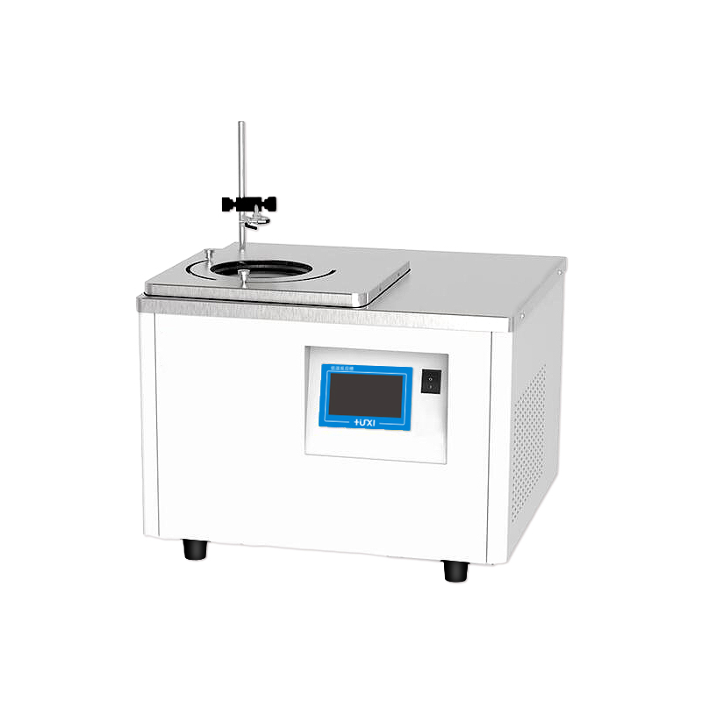

HLM-4003W Magnetic stirring high and low temperature thermostat

1、Application

HLM series magnetic stirring low-temperature reaction tank can be realized by low-temperature constant temperature or high-temperature constant temperature of the sample directly magnetic stirring, without the need for external installation of electric mixer for sample stirring, easy to use and safe. It is suitable for temperature control in chemical synthesis, testing of electronic components at different temperatures, and material testing.

2、Features
- ● The reaction tank with low temperature -20℃ adopts double-stage compressor compound stack refrigeration technology, which is powerful refrigeration and reaches the target temperature faster;
● The use of PID temperature control with advanced proportional refrigeration control technology greatly improves temperature stability;
● The magnetic stirrer inside the vessel is rotating, which can maintain the sample temperature uniformity and good precision for a long time;
● DC brushless motor with long life, trouble-free and infinitely adjustable speed;
● Alarm light and sound reminder at the same time, various alarm codes are displayed to determine the cause of the failure and repair methods;
● A variety of operating modes can be selected, accidental power failure can be automatically restored.
- Technical Parameters
Product Model | HLM-4003W
Product No. | 1032033001
Tank volume (L) | 3
Temperature range (℃) | -40~100
Temperature fluctuation value (℃) | ±0.1
Setting accuracy (℃) | ±0.1
Display precision (℃) | ±0.1
Operating ambient temperature (℃) | 5~32
Speed range (RPM) | 0~1000
Speed regulation mode | Knob
Power supply voltage (V) | 200~230
Display temperature mode | TFT
Setting mode | Touch Screen
Safety Protection | High Temperature Protection Over Temperature Protection
Heating power (W) | 1000
Cooling power(W) | 300
Refrigeration capacity(W) | 450
Refrigerant | R404A
Stirring sub size(MM) | φ8*30
Sink opening(MM) | Φ165
Tank depth size(MM) | 140
Overall Dimension(MM)(W*D*H) | 500*450*370
Packing size(MM)(W*D*H) | 615*565*500
Net weight kg | 38
Gross weight kg | 42
4、Packing list
Name | Qty
Main unit | 1 piece
Retractable tank cover | 1 piece
Magnetic stirrer | 1 piece
Vessel Clamp Column | 1 piece
Vessel clamp | 1 piece
Vessel Clamp Holder | 1 piece
Instruction manual | 1 piece

