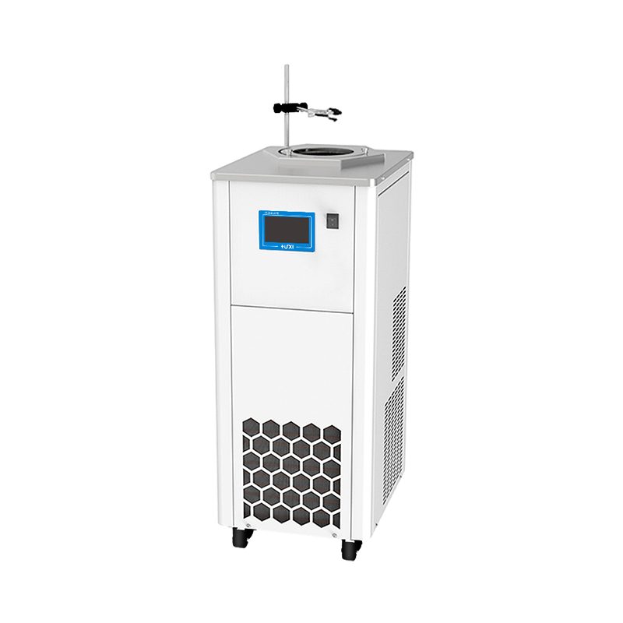

HLM-8005 Magnetic stirring high and low temperature thermostat

1、Application
HLM series magnetic stirring low temperature reaction tank can be realised by low temperature constant temperature or high temperature constant temperature of the sample directly magnetic stirring, without the need for external installation of electric mixer for sample stirring, easy to use and safe. It is suitable for temperature control in chemical synthesis, testing of electronic components at different temperatures, and material testing.
2、Features
● The reaction tank with low temperature -80℃ adopts double-stage compressor compound stack refrigeration technology, strong refrigeration, and reaches the target temperature faster;
● The use of PID temperature control with advanced proportional refrigeration control technology greatly improves temperature stability;
● The magnetic stirrer inside the vessel is rotating, which can maintain the sample temperature uniformity and good precision for a long time;
● DC brushless motor with long life, trouble-free and infinitely adjustable speed;
● Alarm light and sound reminder at the same time, various alarm codes are displayed to determine the cause of the fault and repair methods;
● A variety of operating modes can be selected, accidental power failure can be automatically restored.
- Technical Parameters
Product Model | HLM-8005
Product No. | 1032021001
Tank volume (L) | 5
Temperature range (℃) | -80~20
Temperature stability (℃) | ±0.1
Display precision (℃) | 0.1
Use of ambient temperature (℃) | 5~32
Speed range (RPM) | 100~1200
Speed regulation mode | Touch Screen
Power supply voltage (V) | 200~230
Display temperature mode | TFT
Safety Protection | High temperature protection /Over temperature protection
Heating power (W) | 750
Cooling power(W) | 900
Refrigeration capacity (W) | 400
Refrigerant | R404A+R23
Stirring sub size (MM) | φ8*30
Sink opening(MM) | φ210
Bath size (MM) | φ210*150
Max capacity of reaction vessel(Max diameter) | 1000mL  φ175
Overall Dimension(MM)(W*D*H) | 355*455*865
Packing size(MM)(W*D*H) | 545*430*1300
Net weight (kg) | 62
Gross weight (kg) | 70

- Packing List
Name | QTY
Main unit | 1 piece
Retractable tank cover | 1 piece
Magnetic stirrer | 1 piece
Vessel Clamp Column | 1 piece
Vessel clamp | 1 piece
Vessel Clamp Holder | 1 piece
Instruction manual | 1 piece

