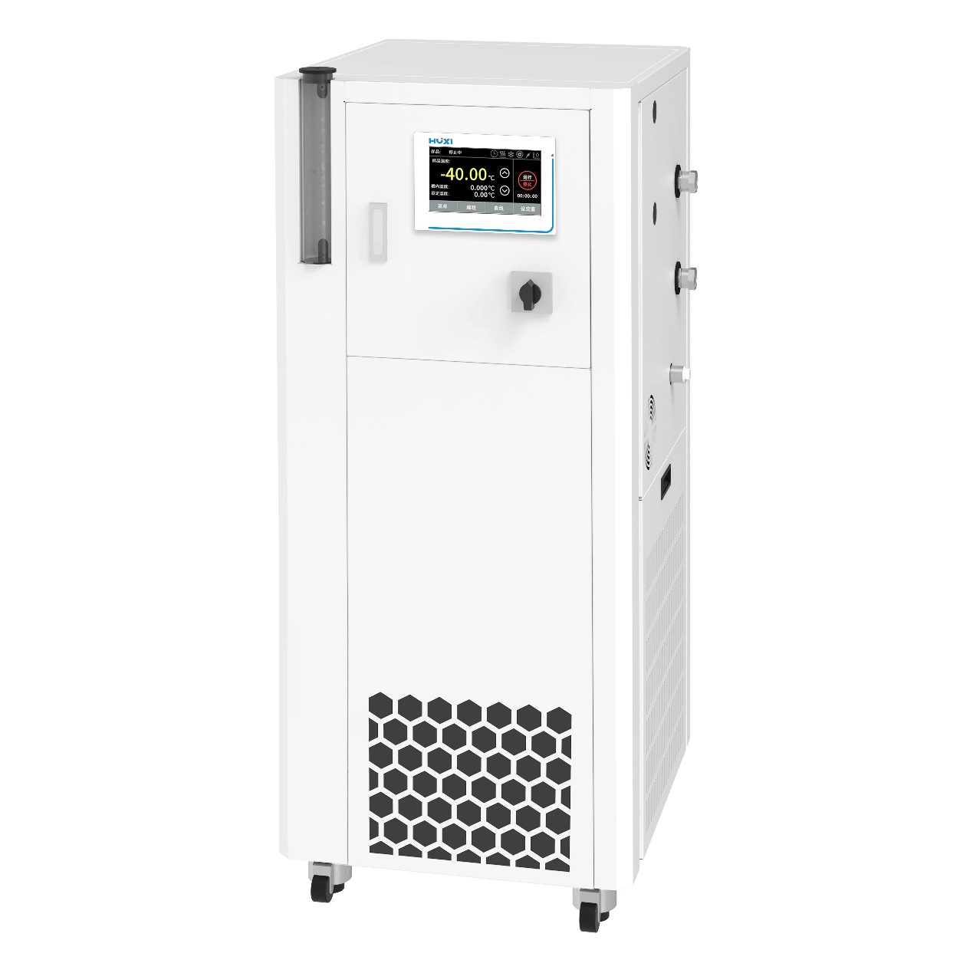

1.Application

      The HDC series is ideally suited for molecular distillation units, microchannel reactors, reactors, and external temperature control required for small-scale production. It offers a wide temperature control range and rapid response to temperature changes. The use of hermetic closure and expansion system, heat transfer oil in the process of high temperature operation, the expansion tank inside the room temperature, so that the heat transfer oil can be used in a wider range of temperatures, as long as to meet the working temperature in the boiling point of the heat transfer oil within 10 degrees can be safe to use; expansion tank automatic cooling system, to ensure that the expansion of the tank of the liquid is always maintained in the ambient temperature, the system is high temperature because of high temperature of the heat transfer medium will not be in contact with the air and water and oxygen, and thus will not oxidize and will not be in contact with the air, so that it will not oxidize. When the system is in high temperature, the high temperature heat conduction medium will not contact with water and oxygen in the air, so it will not oxidize or absorb water in the air, which can improve the stability of the low temperature system and the service life of the heat conduction oil.

2.Product Features

l  7.0-inch touch screen system, LCD display, touch control

l  Imported compressor, proportional refrigeration technology, the output of the refrigeration system is intelligently adjusted according to the external load;

l  Intelligent PID control technology, the heating power of the system is intelligently adjusted;

l  Closed and expansion system, heat transfer oil in the operation process, whether high or low temperature, the expansion tank inside the room temperature, so that the heat transfer oil can be used in a wider range of temperatures

l  Expansion tank in the liquid is always maintained at room temperature, the system at high and low temperatures because of the low temperature of the heat transfer medium will not be in contact with water in the air, will not be deteriorated

l  Internal volume involved in the cycle is small, the external application of warming and cooling fast

l  Double over-temperature alarm technology, the first level in the working cavity has a safety temperature sensor, leakage or liquid shortage of over-temperature can cut off the power supply of the heater, to protect the equipment; the second level of software high and low temperature and high and low temperature alarm, high temperature and low temperature over-temperature can be alarmed to ensure that the equipment is absolutely safe to operate

l  High-quality circulation pump, circulation capacity, to ensure temperature consistency in the internal pipeline and external applications;

l  Set temperature, material temperature, export temperature, temperature curve can be displayed on the screen, each parameter at a glance;

l  Optional configuration of serial RS232/RS485 RTU communication interface, to realize remote monitoring and remote start-stop function.

l  DIN12876-1 standard safety certification, can be used with flammable bath liquid.

3. Technical Parameters

|  |  |
| --- | --- |
| Model | HDC-35S |
| Temperature range | -30~250°C |
| Temperature Stability | ±0.5 °C |
| Temperature display | TFT |
| Display accuracy | 0.001°C adjustable |
| Temperature control mode | Smart PID |
| Control temperature sensor | PT 100 |
| Heating power | 6KW |
| Cooling power (20°C) | 3.5KW |
| Machine inlet and outlet | M30x1.5 mm |
| Maximum pump pressure | 6.0 bar |
| Maximum pump flow | 60 L/min |
| Communication interface | Options RS232/R485 RTU |
| Expansion chamber volume | 10 L |
| Dimension(WxDxH) | 560x650x1300 mm |
| Instrument fixing method | floor-standing |
| Allow continuous operation | 100 % |
| Allowable ambient temperature | 5~32 °C |
| Allowable relative humidity | 80 % |
| Power supply | 3Ø-380V/50Hz |