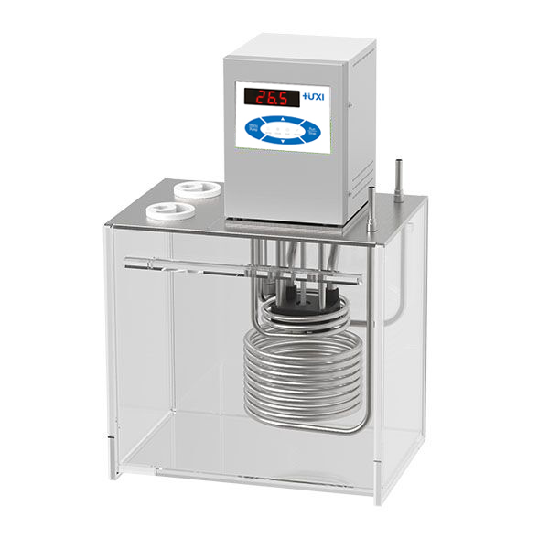

# HLN-2012 Special constant temperature circulator for viscometer

1、Application

A total solution for users who want to measure viscosity manually, the manual viscosity measurement method is the conventional kinematic viscosity measurement method. A two-hole opening for simultaneous measurements is provided as standard. Users need to carry out room temperature point sample viscosity test, need to support the cooling coil, in the cooling coil through the tap water controller can be precise control of the liquid in the tank at room temperature point;

2、Features

1. maintenance-free pressure/suction pump, resistant to fibre and metal particulate matter, while the bath can be stirred horizontally and vertically in both directions to make the mixing more uniform, the pump pressure and flow rate automatically adapted to the external load;

2. low liquid level protection, can be alarmed with light and sound reminders at the same time;

3. and liquid or vapour contact parts using high-performance stainless steel and high-performance plastics;

4. Pt100 temperature sensor, can be multi-point temperature calibration;

5. internal circulation, porous capillary viscometer test position.

3、Technical Parameters

|  |  |
| --- | --- |
| Model | HLN-2012 |
| Item No. | 1032123001 |
| Temperature control range (℃) | 20~100℃ |
| Volume (L) | 12L |
| Temperature control precision (℃) | 0.05℃ |
| Display precision (℃) | ±0.01 |
| Display temperature mode | LED |
| Setting mode | Button |
| External temperature sensor | PT100 |
| Ambient temperature (℃) | 5~32 |
| Power supply voltage (V) | 200~230 |
| Circulation mode | Internal and external calibration |
| Flow rate (L/min) | 12 |
| Lift(M)(Max/Rated) | 3.0/2.0 |
| Circulation interface | 10mm Pagoda Fitting |
| Opening size(mm)(WxDxH) | 108*194*246 |
| Overall Dimension(mm)(WxDxH) | 322*242*452 |
| Packing Size(mm)(WxDxH) | 392*312*522 |
| Net Weight(kg) | 12 |
| Gross Weight(kg) | 12.8 |

4、Packing List

|  |  |
| --- | --- |
| Name | QTY |
| Main unit | 1piece |
| Cooling Coil | 1 piece |
| Certificate of Conformity (with warranty card) | 1 piece |
| Instruction manual | 1 piece |
| Temperature Sensor | 1 piece |