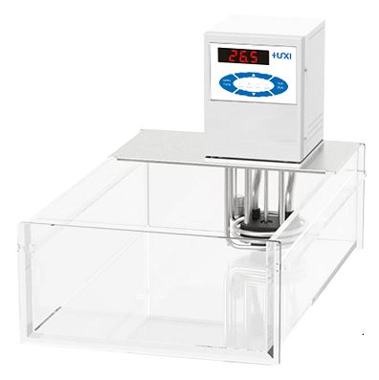

HLC-206EA Open Type Thermostat

1、Application

Widely used with the rotary evaporator cooling; with the reactor system thermostat, biological reactor temperature control; for the cold trap to provide a cooling source; distillation system cooling; for the laboratory to provide the central cooling water; analysis of instruments, such as viscometer external circulation, temperature control of the rheometer, etc.; ultrasonic crushing, disperser cooling, etc.; external open container temperature control and circulation.

2、Features
1. single point calibration function, primary PID control, accuracy ±0.05℃;
2. LED high brightness display, display precision 0.1℃, waterproof operation panel;
3. internal circulation pump, can be horizontal and vertical stirring and mixing of the liquid in the tank, to ensure that the temperature of the liquid in the tank is uniform at all points;
4. double-level safety protection: the first level of low liquid level protection, the second level of high and low temperature protection;
5. three operation modes can be selected, can be set to boot automatically start, can ensure that accidental power failure and then call can be automatically restored;
6. High-performance stainless steel and high-performance plastics are used for parts in contact with liquid or steam.
3、Technical parameters
Model | HLC-206EA
Item No. | 1032099001
Tank volume (L) | 6
Temperature control range (℃) | RT+10~100
Temperature control precision (℃) | ±0.05
Setting precision (℃) | ±0.1
Display precision (℃) | ±0.1
Heating power (W) | 2000
Display temperature mode | LED
Setting mode | Membrane keypad
Safety protection | Low level protection, high temperature protection
Ambient temperature (℃) | 5~32
Power supply voltage (V) | 200~230
Circulation mode | Internal and External Circulation
Flow rate (L/min) | 12
Pump pressure bar | 0.2
Pump suction bar | 0.1
Head(M)(max/rated) | 3.0/2.0
Circulation interface | 10mm Pagoda Fitting
Tank opening (mm)(WxDxH) | 155*135*150
Overall Dimension(mm)(WxDxH) | 180*330*400
Packing Dimension(mm)(WxDxH) | 260*430*465
Net Weight(kg) | 8
Gross Weight(kg) | 10

4、Packing List
Name | Quantity
Main unit | 1 unit
DN8 connector | 2pcs
M16*1 nut | 2pcs
8*12 heat preservation pipe | 1.8m*2pcs
Certificate of Conformity (with warranty card) | 1 copy
Instruction manual | 1 copy

