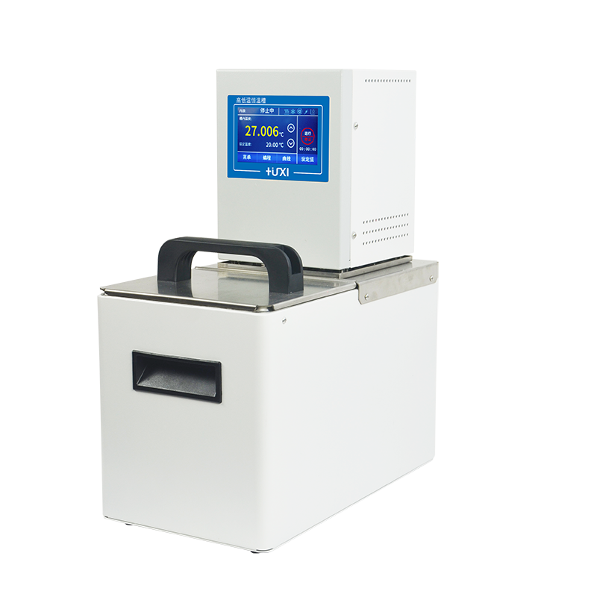

**HLC-217AH Heating Circulators**

**1、Application**

Testing of electronic components at different temperatures, material testing; temperature control in the process of chemical synthesis, process temperature control, such as reaction kettle, molecular distillation; constant temperature control of analytical instrument samples such as matching rheometer for testing.

**2、Features**

* Three-point calibration function;
* Advanced PID control, temperature control accuracy ±0.02℃, maximum temperature 200℃;
* TFT display, display accuracy 0.01℃, touch control, can display the temperature curve in real time;
* Internal circulation: internal circulation pump, which can stir and mix the liquid in the tank horizontally and vertically to ensure uniform temperature at all points of the liquid in the tank;
* external circulation: equipped with an external circulation pump can be closed external circulation thermostat applications, such as: reaction kettle temperature control, etc., but also for the external open large-open container thermostat for more samples experiments
* four levels of safety protection: the first level of low level protection, when the level is low, to remind the user, the user can add liquid operation, wait for the liquid is not added when the shutdown; the second level of adjustable safety temperature protection, dry burning can be cut off in time when the heater power supply; the third level of high temperature and low temperature can be set to limit when the detection of temperature exceeds the set value of alarm and shutdown can be used for flammable liquids The fourth level can only adjust the speed of the pump, when the viscosity of the bath liquid changes, the circulating pump automatically adjusts the output power, pump pressure and flow rate, which effectively protects the circulating pump and prolongs its service life;
* A variety of operating modes can be selected, can be set to start automatically on the power supply, can ensure that accidental power failure and then call can be automatically restored;
* High-performance stainless steel and high-performance plastics are used for parts in contact with liquids or vapours.

1. **Technical Parameters**

|  |  |
| --- | --- |
| Model | HLC-217AH |
| Item No. | 1032214001 |
| Tank volume (L) | 17 |
| Operating temperature range (℃) | RT+5~200 |
| Temperature stability (±K) | ±0.02 |
| Temperature display | TFT |
| Display precision (℃) | 0.01 |
| Temperature control mode | Intelligent PID |
| Control temperature sensor | PT 100 |
| Heating power (KW) | 2 |
| Pump pressure (bar) | 0.4-0.7 |
| Pump suction (bar) | 0.2-0.4 |
| Pump flow [L/min] | 22-27 |
| Pump connection interface | M16x1 |
| Opening size(W×D×H)mm | 295×130×200 |
| Instrument fixing method | Bench Top |
| Allowable continuous operation (%) | 100 |
| Allowable ambient temperature | 5~32 |
| Allowable relative humidity (%) | 80 |
| Power supply voltage/frequency | 200-230VAC/50Hz |
| Dimension(W×D×H)mm | 330×360×450 |
| Packing size(W×D×H)mm | 410×435×540 |
| Net weight (kg) | 12.5 |
| Gross weight (kg） | 13.5 |