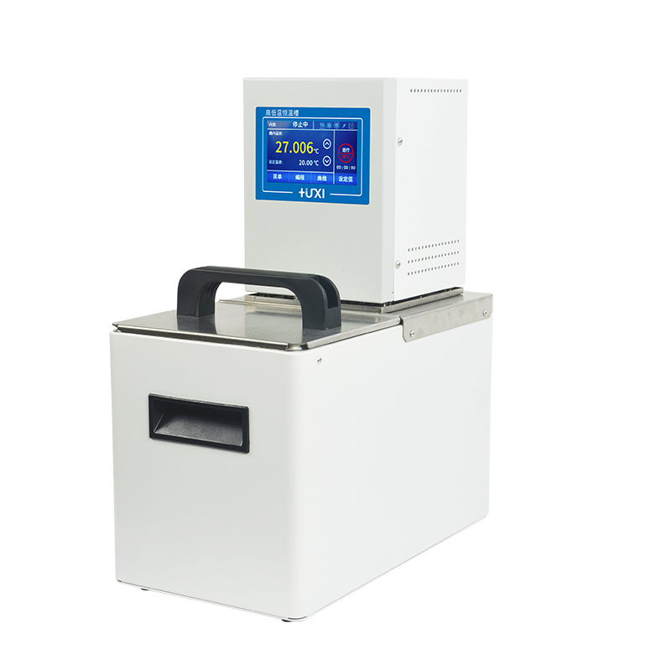

HLC-220SH High Temperature Circulator

1、Application

- Provides a stable heat source for the system
- Stable heating up to 200°C;；
- Temperature control for analytical instruments such as viscometer external circulation, rheometers, etc;
- Temperature control and circulation of external open vessels.

2、Features
- Three-point calibration function;
- Maintenance-free pressure/suction pump with automatic adaptation of pump pressure and flow to external loads;
- Equipped with external temperature sensor for temperature control of external materials (standard type);
- Intermediate PID control, control accuracy ±0.03℃, maximum temperature 200℃;
- TFT display, display accuracy 0.01℃, touch control, the running status of the machine can be displayed on the screen;
- Internal circulation: internal circulation pump, which can stir and mix the liquid in the tank horizontally and vertically to ensure uniform temperature at all points of the liquid in the tank;
- external circulation: equipped with an external circulation pump can be closed external circulation thermostat applications, such as: reactor temperature control, etc., but also for the external open-type large-open container thermostat for more samples experiments, can be equipped with the appropriate accessories for;
- Three-level safety protection: the first level of low level protection, when the liquid level is low, to remind the user, the user can be added to the liquid operation, wait for the liquid is not added to the shutdown; the second level of adjustable safety temperature protection, dry burning can be cut off in time to cut off the power supply of the heater; the third level can be set to limit the high and low temperatures, when the detection of the temperature exceeds the set value of alarms and shutdowns can be used for flammable liquids The third stage can set high and low temperature limits, alarm and shutdown when the detection temperature exceeds the setting;
- Multiple operating modes are available, and automatic start-up can be set for power-on, which ensures that an accidental power failure can be automatically restored when the power comes back on;
- High-performance stainless steel and high-performance plastics are used for parts in contact with liquids or vapours.

3、Technical parameters
Product Model | HLC-220SH
Product No. | 1032097001
Tank volume(L) | 20
Temperature range (℃) | RT+10~200
Temperature control precision (℃) | ±0.03
Display precision (℃) | ±0.01
Circulation mode | Internal and External Cycle
Display temperature mode | TFT
Setting mode | Touch Screen
Heating power (W) | 2000
Use of ambient temperature (℃) | 5~32
Power supply voltage (V) | 200~230
Circulation mode | Internal and External Circulation
Flow rate (L/min) | 22
Pump pressure/suction bar | 0.3/0.2
Head(M)(max/rated) | 2.0/1.0
Circulation interface | 10mm Pagoda Joint
Tank opening (mm)(WxDxH) | 295*295*150
Overall Dimension(mm)(WxDxH) | 335*540*450
Packing Dimension(mm)(WxDxH) | 410*610*520
Net Weight(kg) | 15
Gross Weight(kg) | 18

4、Packing List
Name | Quantity
Main unit | 1 unit
DN8 connector | 2pcs
M16*1 nut | 2pcs
8*12 heat preservation pipe | 1.8m*2pcs
Certificate of Conformity (with warranty card) | 1 copy
Instruction manual | 1 copy

