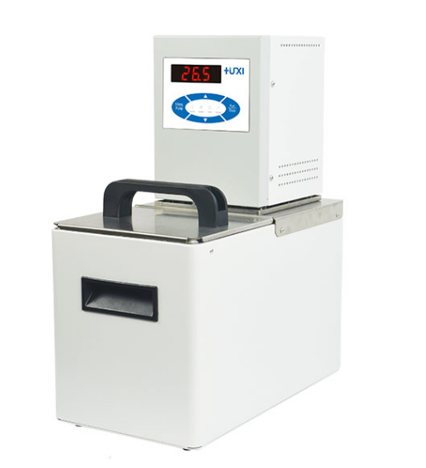

HLC-227E High Temperature Circulator
1、Application

- Provides a stable heat source for the system
- Stable heating up to 150℃;
- Temperature control for analytical instruments such as viscometer external circulation, rheometers, etc.；
- Temperature control and circulation of external open vessels.

2、Features
- Multi-safety protection: low level protection, adjustable over-protection, alarm can be alerted by light and sound at the same time;
- Maintenance-free pressure/suction pump, pump pressure and flow rate automatically adapt to external load;
- Equipped with external temperature sensor, can control the temperature of external materials (standard type);
- Internal parts made of high-performance stainless steel and high-performance plastics;
- A variety of operating modes can be selected, accidental power failure can be automatically restored;

3、Technical Parameters
Model | HLC-227E
Item No | 1032087001
Water Max Capacity(L) | 27
Temp range（℃） | RT+10~100
Temp accuracy（℃） | ±0.05
Setting accuracy（℃） | ±0.1
Display accuracy（℃） | ±0.1
Circulation mode | Internal and external circulation
Display temp mode | LED
Setting mode | Membrane keyboard
Safety protection | Low level protection, high temperature protection
Heating power（W） | 2000
Ambient temperature（℃） | 5~32
Power supply voltage (V) | 200~230
Flow rate (L/min) | 27
Pump pressure (bar) | 0.3
Pump suction(bar) | 0.2
Head(M)(max/rated) | 2.0/1.0
Circulation interface | 10mm Pagoda Fitting
Water tank dimension（mm)(WxDxH) | 295*295*200
Exterior Dimension（mm)(WxDxH) | 335*540*450
Packing Dimension（mm)(WxDxH) | 410*610*520
NW（kg） | 16
GW（kg） | 19

4、Packing List
Name | QTY
Host | 1 Piece
DN8 connector | 2 Pieces
M16*1 nut | 2 Pieces
8*12 heat preservation pipe | 1.8m*2 piece
Certificate of conformity (with warranty card) | 1piece
Manual | 1piece

