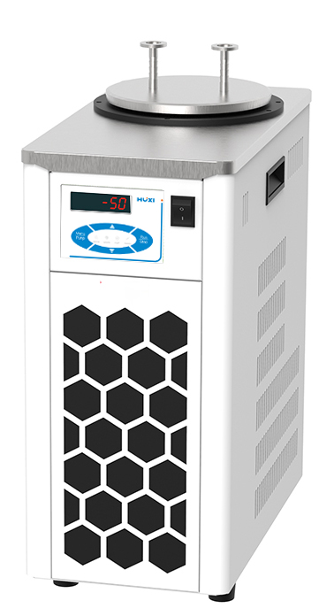

**HLJ-5003** **Cold Trap**

**1、Application**

Capacitor, battery pole piece, battery core drying system; can be used as a pre-frozen tank, low temperature tank; different temperatures of the electronic components test; material testing, etc..

**2、Features**

● Collects water vapour and harmful gases emitted from the drying chamber, synthesis unit, decompression and concentration unit, improves the efficiency of the vacuum pump and prolongs its service life;

● TFT display, touch control, actual and set temperatures are displayed together;

● can reach temperatures as low as -55°C with direct cooling.

● with drain valve for easy liquid discharge;

● Cold trap cover as standard, including one set of inlet and outlet components.

1. **Technical Parameters**

|  |  |
| --- | --- |
| Model | HLJ-5003 |
| Item No. | 1032141001 |
| Minimum Operating Temperature [°C] | -55 |
| Optimum Operating Temperature [°C] | 5~26 |
| Temperature display | TFT, display accuracy 0.1/0.01 |
| Cooling method | Direct Cooling |
| Cooling capacity [W | 600 |
| Dehumidifying capacity [L] | 1,0 |
| Sink volume [L] | 3.0 |
| Interface size [mm] | KF16 |
| Sink opening [mm] | φ162x160 |
| Material | SUS304 |
| Allowable continuous operation [%] | 100 |
| Power supply | 200-230VAC/50Hz |
| Overall dimensions [mm] | 220x420x510(WxDxH) |
| Packing size [mm] | 500x290x560(WxDxH) |
| Net weight [kg] | 28 |
| Gross weight [kg] | 30 |