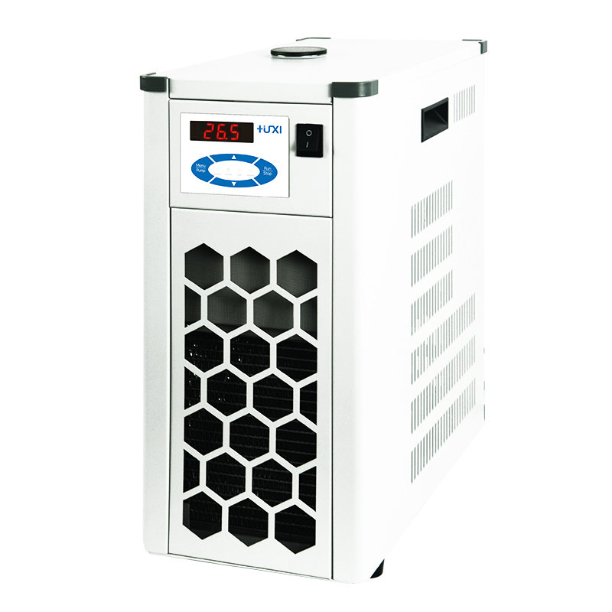

HLL-0520 Flow-through cooler

1、Application
Flow-through coolers can be connected to any heated thermostatic circulator (high temperature thermostat) HLC series HLN series. Upgrading it to a thermostatic circulator with cooling capability enables temperature control at or below ambient temperature. Provides a stable flow rate and cooling temperature independent of external influences.

2、Features
1、Using air-cooled heat dissipation, the bath is fully enclosed, maintenance-free refrigeration equipment;
2、The enclosed bath is made of high quality stainless steel, corrosion-resistant and with long service life;
3, low noise, small size, does not occupy space.
- Technical Parameters
Model | HLL-0520
Item No. | 1040004001
Temperature range ℃ | -5~40
Temperature uniformity ℃ | ±2
Refrigeration powerw | 200(20℃)
Alarm function | yes
Water tank volume L | 3
Overall dimensions mm | 200*340*300
Packing size mm | 250*390*350
Net weight kg | 26
Gross weight kg | 28

