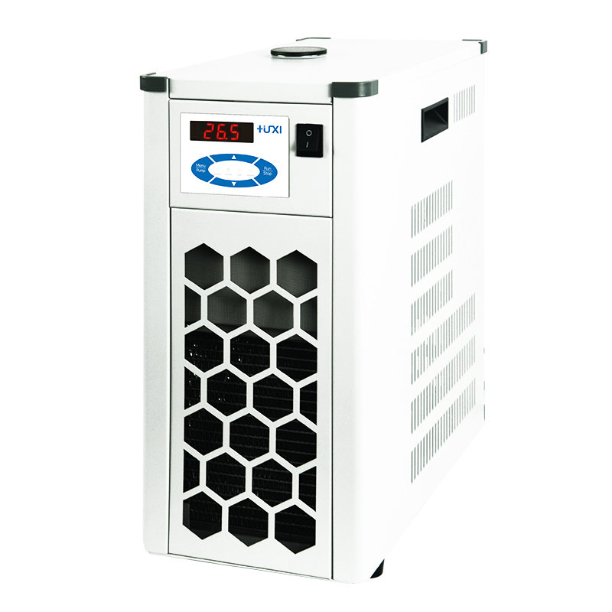

HLL-4015 Flow-through coolers
1、Application
Flow-through coolers can be connected to any heated thermostatic circulator (high temperature thermostat) HLC series HLN series. Upgrading it to a thermostatic circulator with cooling capability enables temperature control at or below ambient temperature. Provides a stable flow rate and cooling temperature independent of external influences.

2、Features
1、Using air-cooled heat dissipation, the bath is fully enclosed, maintenance-free refrigeration equipment;
2、The enclosed bath is made of high quality stainless steel, corrosion-resistant and with long service life;
3, low noise, small size, does not occupy space.
- Technical Parameters
Model | HLL-4015
Temperature range ℃ | -40~RT
Temperature uniformity ℃ | ±0.5
Cooling capacity w | 1500(20℃)
Alarm function | Yes
Bath volume L | 3
Connector size mm | Stainless Steel Pagoda Fitting 10
Overall dimension mm | 200*500*620

