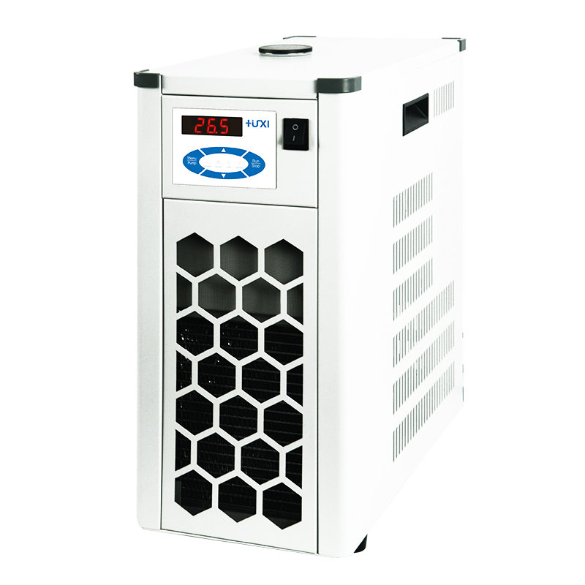

HLL-4080 Flow-through coolers

1、Application
Flow-through coolers can be connected to any heated thermostatic circulator (high temperature thermostat) HLC series HLN series. Upgrading it to a thermostatic circulator with cooling capability enables temperature control at or below ambient temperature. Provides a stable flow rate and cooling temperature independent of external influences.

2、Features
1、Using air-cooled heat dissipation, the bath is fully enclosed, maintenance-free refrigeration equipment;
2、The enclosed bath is made of high quality stainless steel, corrosion-resistant and with long service life;
3, low noise, small size, does not occupy space.
- Technical Parameters
Model | HLL-4080
Temperature range ℃ | -40~150
Temperature uniformity ℃ | ±0.5
Cooling capacity w | 800(20℃)
Alarm function | Yes
Water tank volume L | 5
Overall dimensions mm | 220*420*495
Packing size mm | 500*290*560
Net weight kg | 28
Gross weight kg | 30

