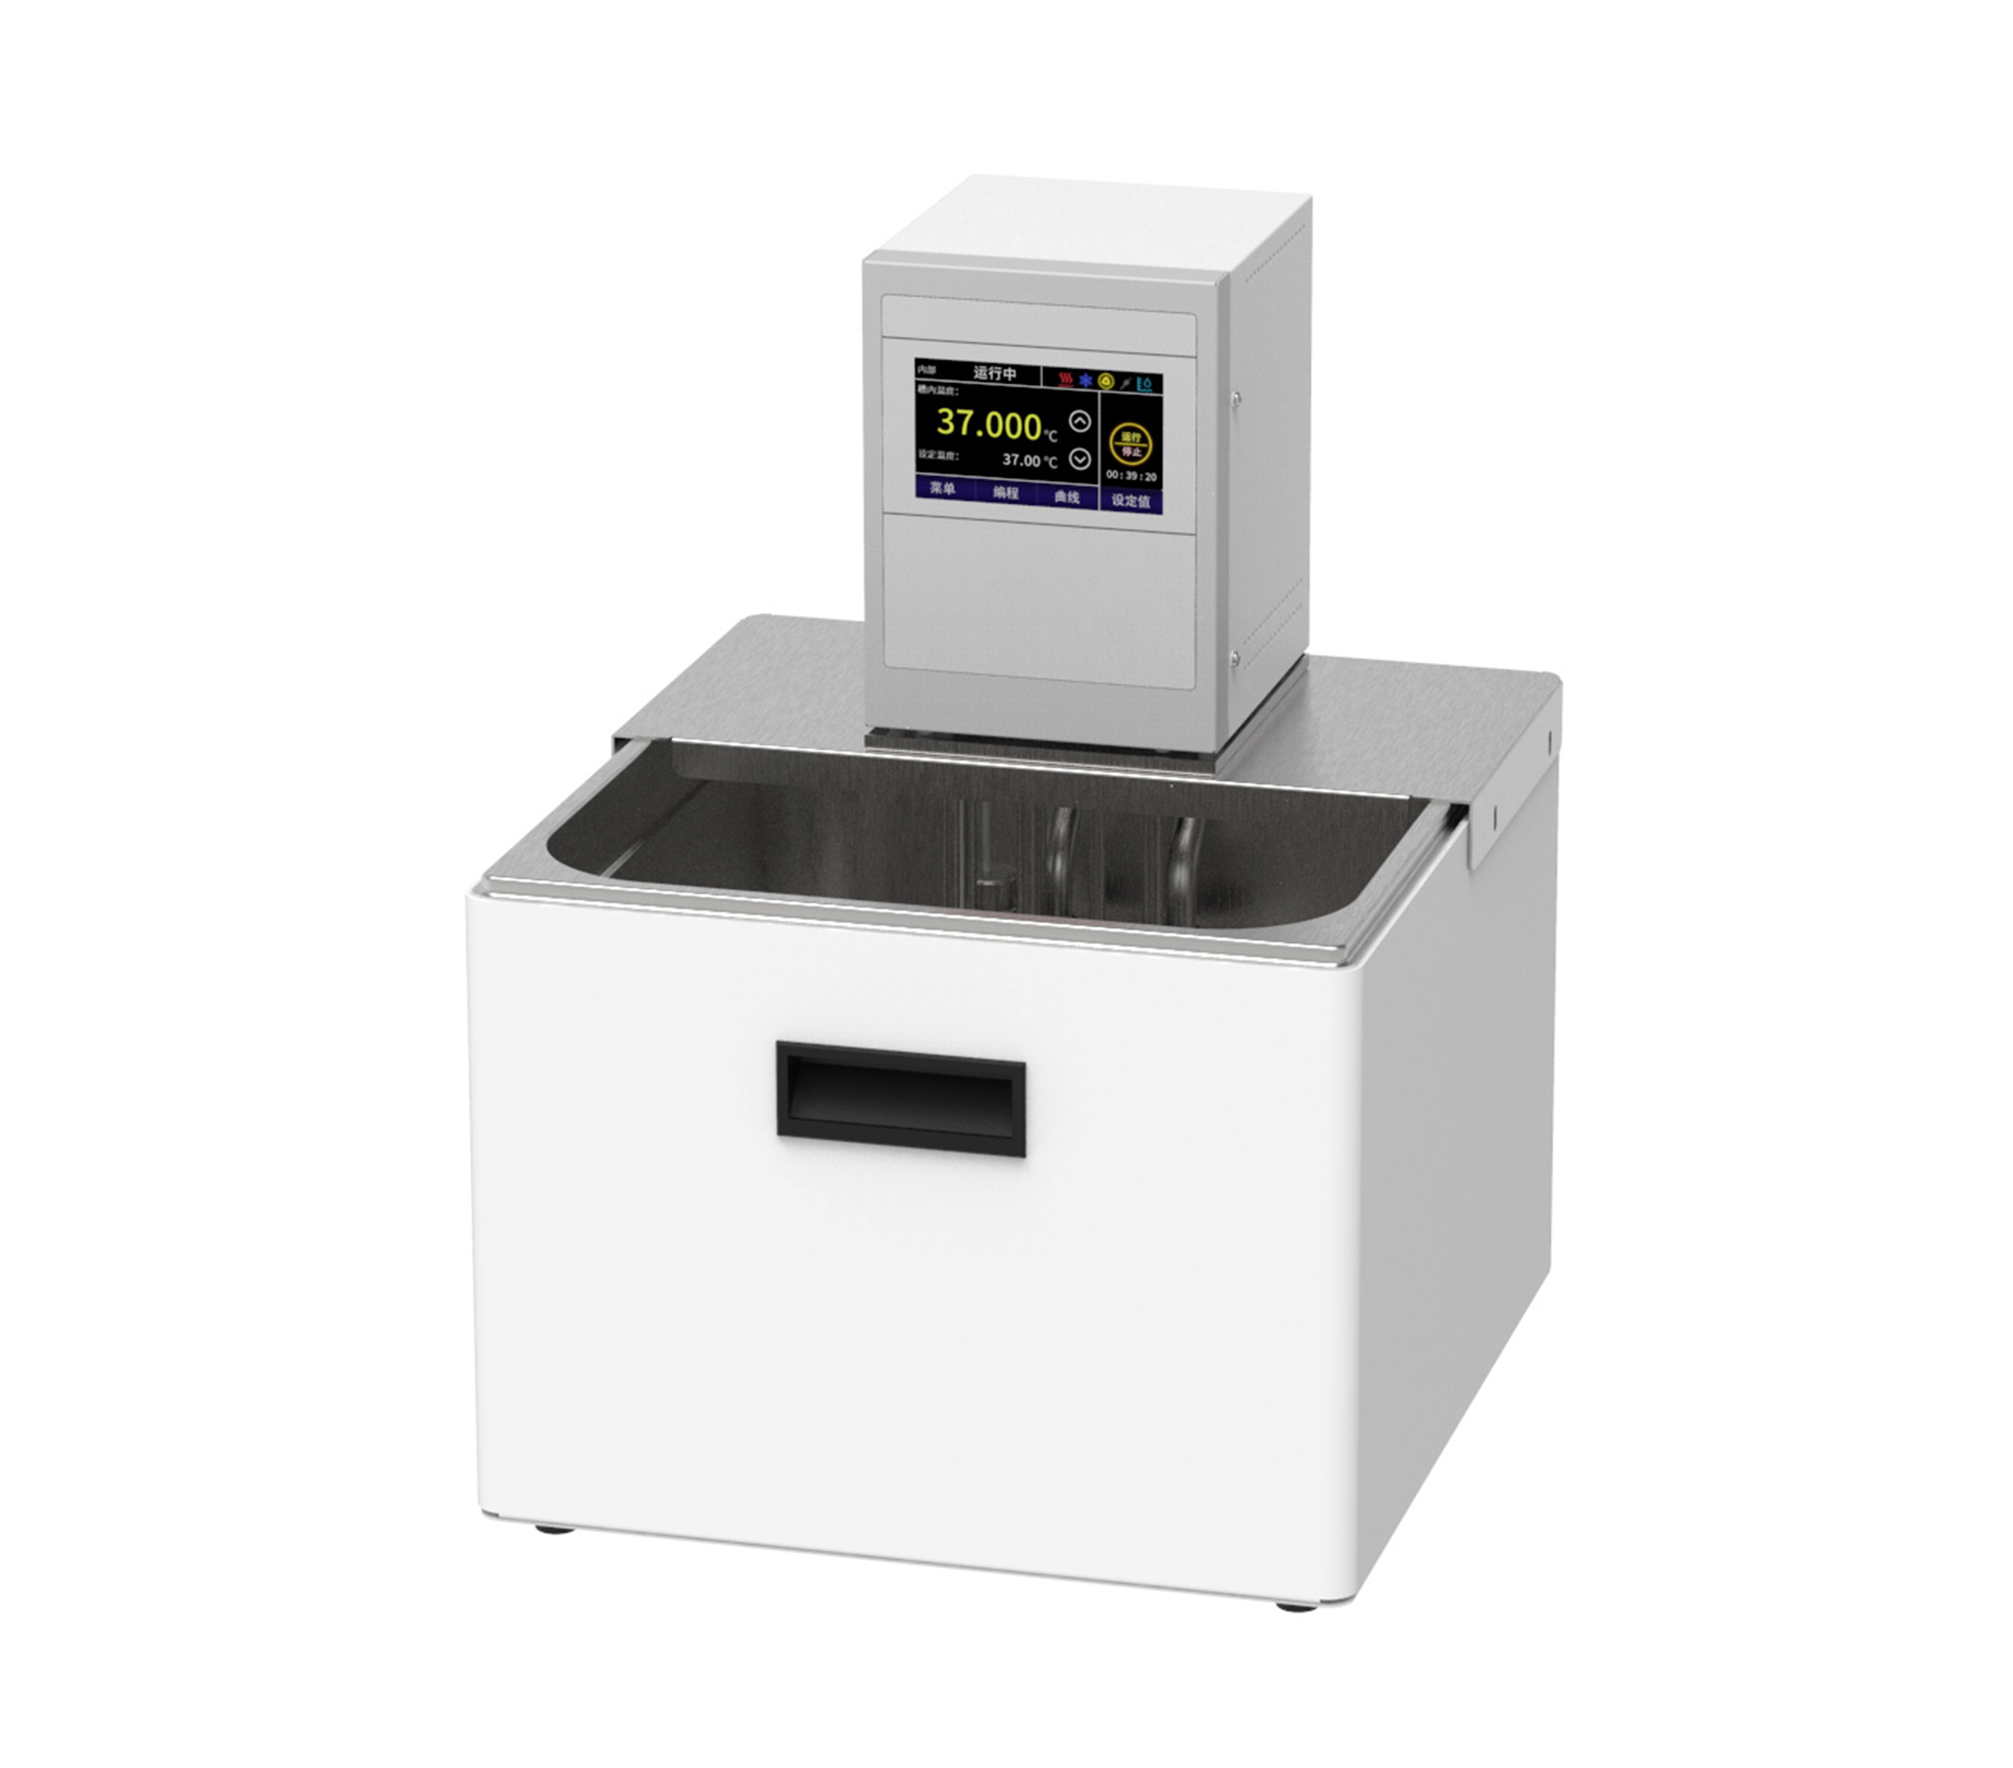

HLC-213SHB High Temperature Circulator

1、Application

- Testing of electronic components at different temperatures, materials testing.
- Temperature control during chemical synthesis.
- Process temperature control.
- Thermostatic control of samples such as matching viscometers for testing.
- Quality control.
2、Features
- Single point calibration function;
- Primary PID control with ±0.03°C control accuracy;
- Internal circulation function;
- With drain valve, convenient for users to drain the liquid;
- Dual-stage safety protection: the first level of low liquid level protection, the second level can be high and low temperature protection;
- Three operation modes are available, can be set to start automatically when the power is switched on, which can ensure that accidental power failure can be automatically restored when the power comes back on;
- Parts in contact with liquid or vapour are made of high performance stainless steel and high performance plastics.

3、Technical Parameters
 | HLC-213SHB
Product Model | 1032118001
Product No. | 13
Tank volume(L) | RT+10~200
Temperature range (℃) | ±0.03
Temperature control precision (℃) | Internal Cycle
Circulation mode | TFT
Display temperature mode | Touch Screen
Setting mode | 2000
Heating power (W) | 5~32
Use of ambient temperature (℃) | 12
Flow rate (L/min) | 0.2
Pump pressure bar | 0.1
Pump suction bar | 2.0/1.0
Lift (M)(max/rated) | 10mm Pagoda Joint
Circulation interface | 295*130*150
Tank opening (mm)(WxDxH) | 330*360*450
Overall Dimension(mm)(WxDxH) | 400*430*520
Packing Dimension(mm)(WxDxH) | 12.5
Net Weight(kg) | 14.5

