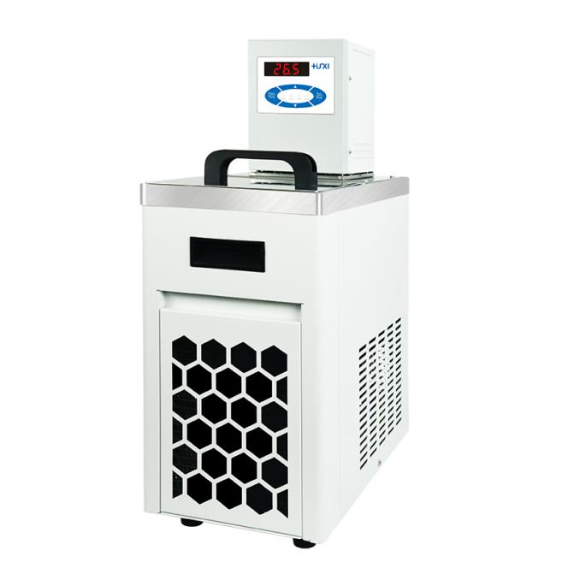

HLC-2005E Vertical High and Low Temperature Thermostat

1、Application

HLC series vertical high and low temperature constant temperature bath is widely used in biology, chemical industry, chemistry, pharmacy, life sciences, physical testing and other industries, colleges and universities, enterprise quality inspection. For the user experiments and production to provide a hot and cold controlled, uniform and constant temperature field source, the test samples or production of products for constant temperature test or test, can also be used as a direct heating or refrigeration and auxiliary heating or refrigeration of the heat or cold source.
2、Product Features

- Maintenance-free pressure/suction pump, resistant to fibre and metal particulate matter, simultaneously agitates the bath both horizontally and vertically for more even mixing;
- Multi-safety protection: low level protection, light and sound alerts when alarms are available;
- Parts in contact with liquids or vapours are made of high-performance stainless steel and high-performance plastics;
- Pt100 temperature sensor for single and two-point temperature calibration;
- internal circulation with two different heights of cup holders as standard for different cups Temperature and viscosity testing in the bath;
- external cycle for thermoregulation of the viscometer's bath jacket, suitable for the viscometer to be used outside the bath for sample viscosity testing in the bath jacket. can be externally circulated to thermoregulate the bath jacket of the viscometer for viscosity testing of samples in the bath jacket outside the viscometer;
- The buzzer can be set to silent or audible.

3、Technical Parameters

Product Model | HLC-2005E
Product No. | 1032040001
Tank volume(L) | 5
Temperature range (℃) | -20~100
Temperature control stability (℃) | ±0.05
High temperature straight down | /
Circulation mode | Internal and External Circulation
Use of ambient temperature (℃) | 5~32
Power supply voltage (V) | 200~230
Display temperature mode | LED
Setting mode | Membrane Keypad
Safety protection | Low level protection, high temperature protection
Heating power (W) | 2000
Cooling power(W) | 400
Refrigerant | R134a
Water pump flow(L/min) | 22
Pump pressure bar | 0.3
Pump suction bar | 0.2
Head(M)(max/rated) | 2.0/1.0
Circulation interface | 10mm Pagoda Fitting
Tank opening(mm)(WxDxH) | 166*38*150
Overall Dimension(mm)(WxDxH) | 230*400*615
Outer tank size(mm)(WxDxH) | 300*470*685
Net weight kg | 23.5
Gross weight kg | 26

4、Packing List
Name | Quantity
Main unit | 1 unit
DN8 connector | 2pcs
M16*1 nut | 2pcs
8*12 heat preservation pipe | 1.8m*2pcs
Certificate of Conformity (with warranty card) | 1 copy
Instruction manual | 1 copy

