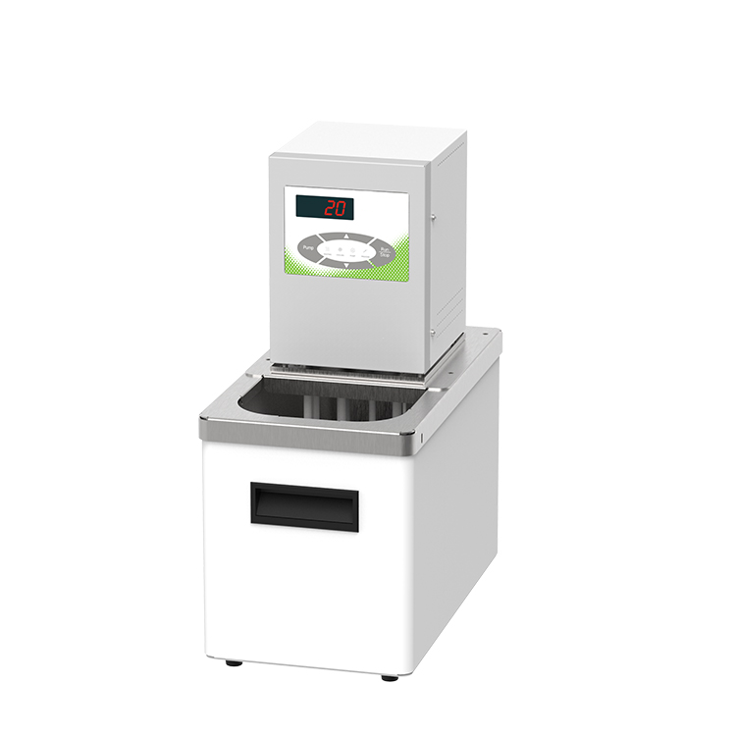

HLC-206EB High Temperature Circulator

1、Application

- Testing of electronic components at different temperatures, materials testing.
- Temperature control during chemical synthesis.
- Process temperature control.
- Thermostatic control of samples such as matching viscometers for testing.
- Quality control.
2、Features
- Single point calibration function;
- Primary PID control with ±0.5°C control accuracy;
- Internal circulation function;
- With drain valve, convenient for users to drain the liquid;
- Dual-stage safety protection: the first level of low liquid level protection, the second level can be high and low temperature protection;
- Three operation modes are available, can be set to start automatically when the power is switched on, which can ensure that accidental power failure can be automatically restored when the power comes back on;
- Parts in contact with liquid or vapour are made of high performance stainless steel and high performance plastics.
3、Technical Parameters
Product Model | HLC-206EB
Product No. | 1032104001
Tank volume(L) | 6
Temperature range (℃) | RT+10~100
Temperature control precision (℃) | ±0.05
Setting precision (℃) | ±0.1
Display precision (℃) | ±0.1
Circulation mode | Internal Cycle
Display temperature mode | LED
Setting mode | Membrane keypad
Heating power (W) | 2000
Use of ambient temperature (℃) | 5~32
Flow rate (L/min) | 12
Pump pressure bar | 0.2
Pump suction bar | 0.1
Lift (M)(max/rated) | 2.0/1.0
Circulation interface | 10mm Pagoda Joint
Tank opening (mm)(WxDxH) | 150*105*150
Overall Dimension(mm)(WxDxH) | 180*330*400
Packing Dimension(mm)(WxDxH) | 260*430*465
Net Weight(kg) | 8
Gross Weight(kg) | 10

