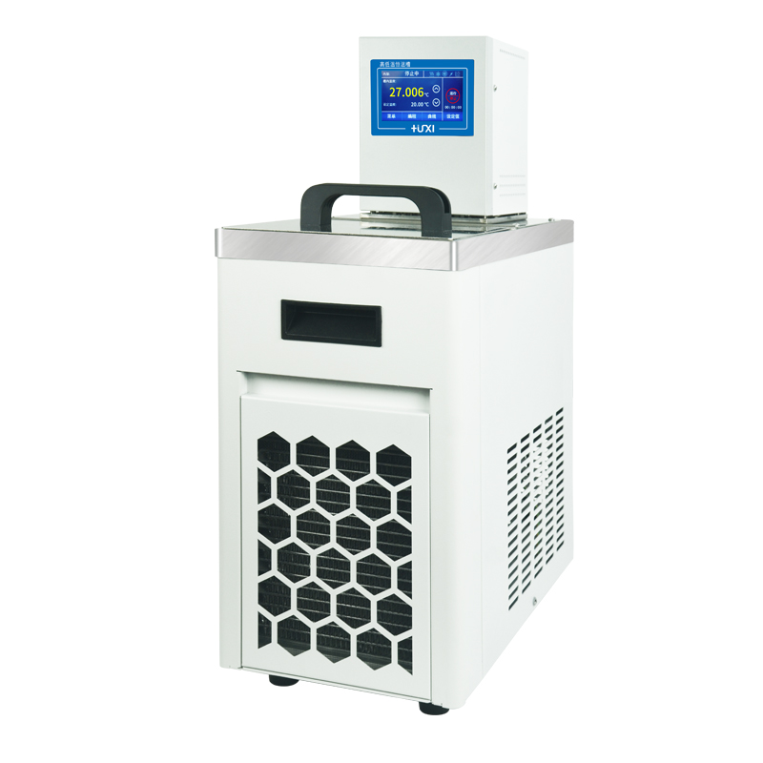

HLC-4005SH High and Low Temperature Thermostats

1、Application

HLC SH series vertical high and low temperature constant temperature bath is widely used in biology, chemical industry, chemistry, pharmacy, life science, physical properties testing and other industries of higher education, enterprise quality inspection. For the user experiment and production to provide a heat and cold controlled, uniform and constant temperature field source, the test samples or production of products for constant temperature test or test, can also be used as a direct heating or refrigeration and auxiliary heating or refrigeration of the heat or cold source.
2、Product Features

- Maintenance-free pressure/suction pump, resistant to fibers and metal particulate matter, simultaneously agitates the bath both horizontally and vertically for more uniform mixing;
- Multi-safety protection: low liquid level protection, can be alarmed with both light and sound alerts;
- High performance stainless steel and high performance plastics are used for parts in contact with liquid or vapor;
- Pt100 temperature sensor for single and two-point temperature calibration;
- Can be internal circulation ,which comes standard with two different heights of cup holders for thermoregulation and viscosity testing of different cups inside the bath;
- Can be external circulation for thermoregulation of the water bath jacket of the viscometer, suitable for viscosity testing of samples in a water bath jacket outside the bath;
- The buzzer can be set to silent or audible.
- Touch screen
3、Technical Parameters
Product Model | HLC-4005SH
Product No. | 1032070001
Tank volume(L) | 5
Temperature range (℃) | -40~200
Temperature control fluctuation value (℃) | ±0.03
Setting accuracy (℃) | ±0.1
Display precision (℃) | ±0.01
High temperature direct drop | Yes
Circulation mode | Internal and External Circulation
Use of ambient temperature (℃) | 5~32
Power supply voltage (V) | 200~230
Display temperature mode | Touch panel digital display
Setting mode | Touch screen
Safety protection | Low liquid level protection, high temperature protection
Heating power (W) | 2000
Cooling power(W) | 600
Refrigerant | R134a
Water pump flow (L/min) max/rated | 22
Pump pressure bar | 0.3
Pump suction bar | 0.2
Head(M)(max/rated) | 2.0/1.0
Circulation interface | 10mm Pagoda Fitting
Tank opening(mm)(WxDxH) | 166*38*150
Overall Dimension(mm)(WxDxH) | 230*400*720
Packing size(mm)(WxDxH) | 300*470*790
Net weight kg | 25.5
Gross Weight(kg) | 28

4、Packing List
Name | Quantity
Mainframe | 1 unit
DN8 connector | 2pcs
M16*1 nut | 2pcs
8*12 Insulation pipe | 1.8m*2pcs
Instruction manual | 1pc

