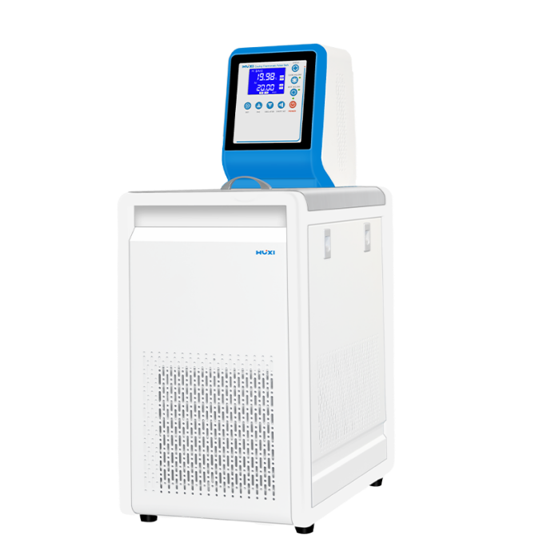

# HLC-8006 Ultra Low Temperature Thermostats

**1、Product Application**

Ultra-low temperature constant temperature tank using the latest international advanced refrigeration system, stable and reliable performance. With internal and external circulation: internal circulation can also test samples or production of products in the tank directly for constant temperature test or test, external circulation function through the high-pressure pump to the tank liquid medium circulation thermostat, increase the uniformity of the tank temperature, reduce temperature fluctuations. The principle is to use the water outlet through the thermal insulation hose will be the tank thermostatic medium outside, the establishment of external constant temperature, for testing experiments or production to provide a constant temperature thermostatic coolant, temperature uniformity and constant liquid environment, thermostatic coolant can be recycled and reused.

1. **Product Features**

large screen backlit LCD, set temperature, actual temperature, can independently start/close the "heating", "cooling", "internal and external circulation" and other functions. The control part is made of ABS mold;

* The control part adopts ABS molding design; fine chassis front panel and countertop, together with unique humanized R rounded corner design structure, can avoid the operator inadvertently hurt by the chassis corners; the whole set of packaging adopts molding foam, up and down molding, can avoid the damage caused by the transportation;
* high-performance stirring circulating motor, low noise, low heat, fully enclosed, high life expectancy; the use of heatless circulating pump, to avoid the traditional pump due to its own heat and affect the tank temperature field;
* 304 stainless steel table plate, liner, in addition to the refrigeration coil increased positioning and surface treatment process, can effectively solve the refrigeration coil transportation or use of shaking or avoid corrosion, rust and other phenomena;
* motor impeller is fully enclosed to prevent causing safety hazards; multiple safety protection: low liquid level of the heating tube empty burn protection, alarm lights and sound reminders at the same time;
* with power failure protection, over-temperature alarm function, to provide a number of security measures;
* Fully enclosed compressor unit refrigeration, refrigeration system with overheating, overcurrent multiple protection devices;
* The instrument is purposely designed with a flexible removable door panel all around, in order to have a better cooling effect, and after a long time of work, it is convenient and concise to clean up the dust, and there is no need for any dismantling tools;
* The instrument works stably and reliably, the operation is convenient and safe, and the instrument has temperature calibration and self-tuning function;
* Circulation interface and drainage port all adopt 304 stainless steel pagoda connector, installation is fast and reliable.

**3、Technical Parameters**

|  |  |
| --- | --- |
| Model | HLC-8006 |
| Item No. | 1032255001 |
| Tank capacity(L) | 6L |
| Temperature range | -80~100℃ |
| Cooling mode | Compound (two compressors for refrigeration) |
| Heating power | 1500W |
| Display accuracy | 0.1℃ |
| Inner tank size | 270*200*130mm |
| Size of working tank opening | 180*140mm |
| Flow rate of external circulation | 8L/min |
| Water Lift | 2M |
| Pump pressure | 0.1bar |
| Temperature display mode | LED |
| Refrigeration capacity of one-stage compressor | 2200W |
| Refrigeration capacity of second stage compressor | 3700W |
| Refrigerant of one-stage compressor | 410A |
| Refrigerant for two-stage compressor | Non-standard mixed customization |
| Liquid injection valve device | Standard |
| Instrument size (L*W*H) | 560*420*1080mm |
| Package size (L*W*H) | 660*480*1220mm |
| Net weight | 70kg |
| Gross Weight | 85kg |
| Packing | Wooden case |
| Optional Functions | Temperature control precision 0.01℃ |
| Fixed flask holder |

|  |  |  |
| --- | --- | --- |
| No | Name | Qty |
| 1 | Mainframe | 1 unit |
| 2 | Power cord | 1 unit |
| 3 | Thermostatic silicone tube 1 meter | 2pcs |
| 4 | Stainless steel cover | 1 piece |
| 5 | Instruction manual | 1 piece |
| 6 | Certificate of Conformity (with warranty card) | 1 Piece |
| 7 | Drainage pipe | 1 piece |
| 8 | Fuse | 2 pieces |

**4、Packing List**