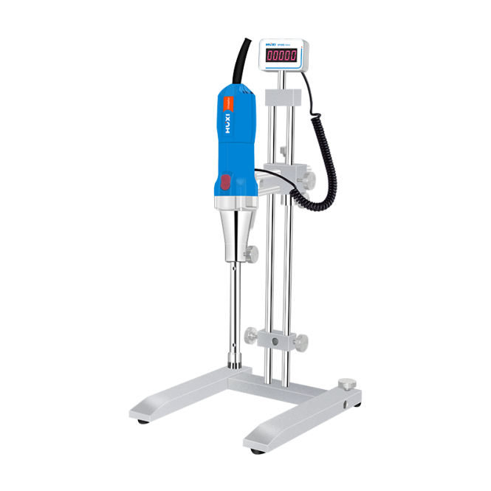

# **HR-500D High Shear Homogenizer**

**Application：**

● The digital display high shear homogenizer emulsifying machine integrates dexterity and convenience. It can realize vacuum operation or hand-held operation, and can easily meet various experimental requirements of high dispersion, emulsification and homogenization;

● The rotating speed can reach 28000rpm, and more than 20 kinds of working heads are available. The high-speed rotating rotor is combined with the precise working chamber of the stator. Relying on the high linear speed, it produces strong hydraulic shearing, centrifugal extrusion, and high-speed cutting and collision, so that the The material is fully dispersed, emulsified, homogenized, pulverized and mixed, and finally a stable high-quality product is obtained;

● Mainly used in pharmaceutical, biochemical, food, nanomaterials, coatings, adhesives, daily chemicals, printing and dyeing, petrochemicals, papermaking chemistry, polyurethane, inorganic salts, asphalt, silicone, pesticides, water treatment, heavy oil emulsification and other industries.

**Main Features：**

● Selection of high-quality motor, stable operation, lower noise, long-term operation, safe and reliable design;

● All parts of the working head contacting materials are made of high-quality stainless steel, with good corrosion resistance;

● The working head is connected with the drive motor by a coupling, which is easy and flexible to disassemble and assemble;

● The speed regulating machine base adopts stepless speed regulator, which is convenient for speed regulation and stable in operation.

**Techncial Parameters：**

|  |  |
| --- | --- |
| Model | HR-500D |
| Power supply | 220V/50/60Hz |
| Range of rotation | 10000-31000rpm |
| Speed display mode | Digital Display |
| Speed mode | Stepless speed regulation |
| Processing capacity | 0.2ml-7000ml(H2O) |
| Standard working head | 25G |
| Contact material | SUS316L |
| Immersion material shaft sleeve material | PTFE |
| Speed deviation | 1% |
| Maximum viscosity | 5000CP |
| Process type | Batch processing |
| Allowable ambient temperature | 5-40 degrees |
| Relative humidity | 80% |
| Set Weight | 9KG |
| Set packing dimension | 470×330×200mm |
| Host dimension | 275×φ65mm |
| Host Net weight | 4kg |