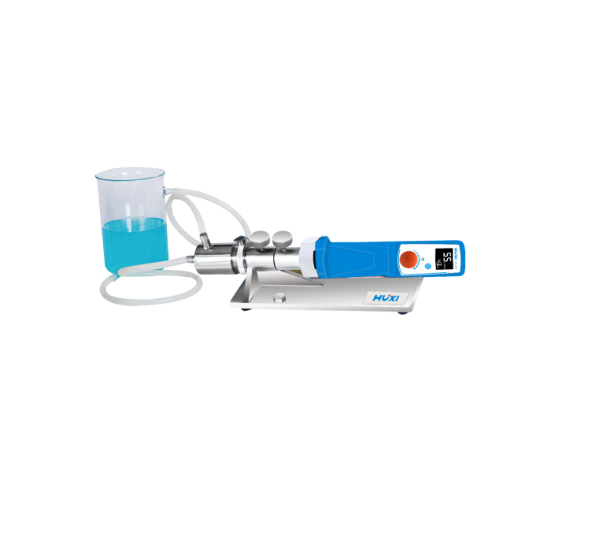

# **HZR-25D Online homogenizer**

**Application：**

● HZR-25D online emulsifier has high emulsification and mixing efficiency, light weight, modular structure of the whole machine, easy to operate, and can run for a long time. Can make the material 100% through the shear cavity, efficient homogeneity, no dispersion dead angle and other characteristics. Easily meet the simulation of online working conditions in the laboratory for circulation or online continuous processing. Applicable process: Laboratory online processing, can cycle the material, complete online dispersion, emulsification, homogenization and mixing.

**Main Features：**

● High speed motor with brushless motor and long life design for continuous and long time stable operation;

● The highest speed can reach 26000rpm, providing you with a maximum shear line speed of 27m/s;

● The working head and machine base are made of stainless steel, corrosion resistant;

● Better sealing effect, unique stator-rotor structure, generating super strong shearing force, rapidly reducing the particle size, handling materials more finely and dispersing more uniformly.

**Techncial Parameters：**

|  |  |
| --- | --- |
| Model | HZR-25D |
| Item No | 1004028001 |
| Motor power | 750W |
| Motor type | DC brushless motor |
| Speed range | 4000~26000rpm |
| Speed control mode | Knob adjust |
| Speed display | LCD display |
| Capacity（H20） | 1-20L/min |
| Max viscosity | 10000CP |
| Standard working head | 25DG |
| Standard working chamber | Stainless steel non-jacketed working chamber |
| Contact material | SUS316L |
| Mechanical seal material | SiC |
| Hygiene standard | GMP pharmaceutical hygiene   standard |
| Inlet and outlet outer diameter | 14 (hose interface) |
| Overall dimension | 460×120×120mm |
| Working bracket, base, disassembler | Stainless steel standard |
| Power supply | 220V/50Hz |
| Allowable ambient temperature | 5-40℃ |
| Allowable ambient humidity | 80% |