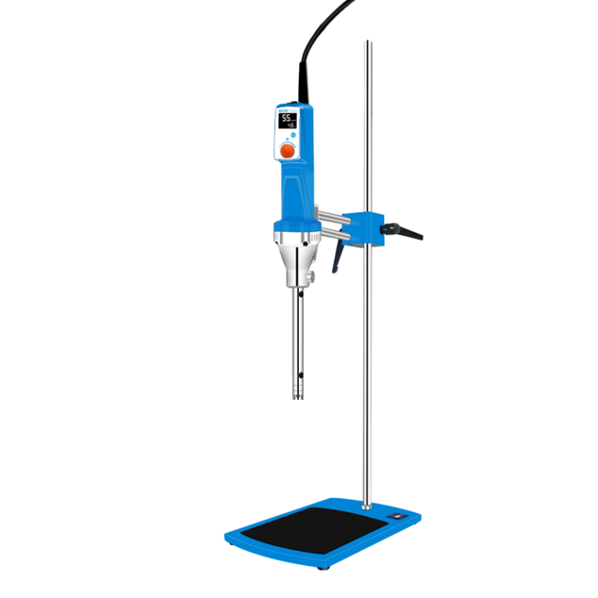

# HR-25D Laboratory Homogenizer

**Application：**

● HR-25D laboratory homogeneous emulsifier is a mechanical equipment specially designed for sample homogeneous emulsification. It can be equipped with a variety of working heads of different specifications to quickly realize sample dispersion, homogenization, emulsification, suspension, stirring, etc. At present, it has been widely used in biological animal and plant tissue cells, medicine, cosmetics, food, medicine, chemical industry and many other fields.

**Main Features：**

● A variety of different specifications of the working head, to meet the 0.2 ~ 10000ml processing volume, applicable to different sample processing requirements;

● 4000~26000 rpm can be set arbitrarily, with 0~999min timer function, and the instrument stops automatically at the end of operation;

● The whole machine has a compact structural design and exquisite modelling, providing a linear speed of 27m2/s for sample homogenisation;

● Bi-directional support bar design combined with double-hole fixed clamps to form an integrated lifting and adjusting system to make your experiments,

reliable and safer;

● Can be equipped with a temperature sensor, real-time measurement of sample temperature, reaching the set value, automatically stop running, better

protection of samples, so that the experiment is safe and secure.

**Techncial Parameters：**

|  |  |
| --- | --- |
| Model | HR-25D |
| Item No | 1004022000 |
| Type | Digital |
| Rated Voltage (V) | 200-240 |
| Frequency | 50/60HZ |
| Rated Input Power | 1050W |
| Rated Output Power | 750W |
| Max input power | 1350w |
| Max output power | 1050w |
| Motor type | Brushless motor |
| Speed range | 4000-26000rpm |
| Speed accuracy | ±100rpm |
| Speed mode | LCD |
| Speed control | Knob adjust |
| Capacity | 0.2-10000ml（with different working heads） |
| Time Range | 0-999 |
| Time Display | LCD |
| Temperature testing range | -10~199℃ |
| Set Standard | Machine+working head+stand |
| Standard working head | HR25 25g-S2V |
| Machine Size | 365*90mm |
| Machine packing Size | 470*340*205mm |
| Machine NW | 2.5KG |
| Machine GW | 2.9KG |
| Set NW | 6.5KG |
| Set GW | 9KG |