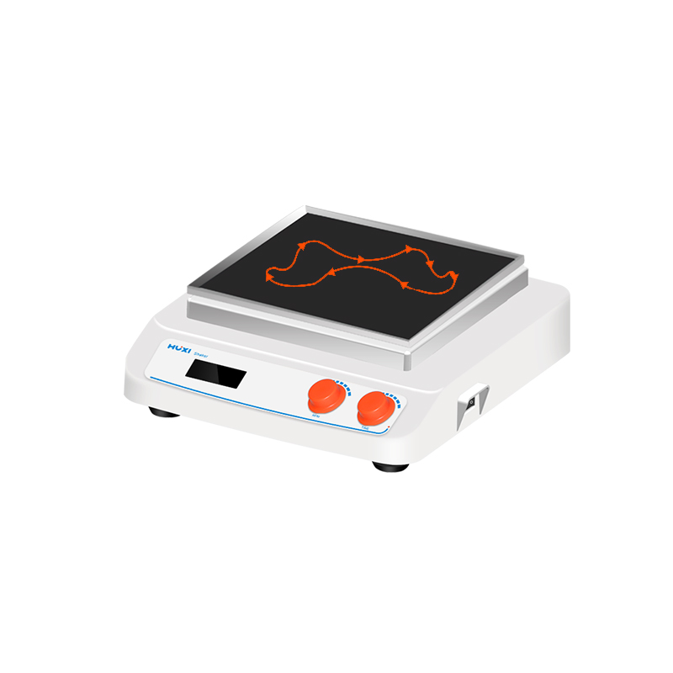

# **HT-S330 Three-dimensional Shaker**

# HT-S330 **Rotary Shaker**

**Application：**

The HT-S330 is a 3D shaker for electrophoresis gel staining/decolourisation, sample washing, molecular hybridisation, sedimentation, protein blotting, cell culture, etc. It can also be used for cell culture and cell membrane transfer, and can be placed in cryogenic and thermostatic chambers.

**Main Features：**

* Moulding shell is acid and alkali resistant, no deformation, easy to clean;
* With skirt power switch and timing, speed control and power holder jacks, which can prevent corrosion of power supply short circuit to the switch, speed control timing parts in case of liquid spillage;
* The motor is designed with wide voltage to meet the needs of different regions, three-dimensional tumbling, tilting angle up to 10 °;
* Maximum load capacity is 5kg (including clamps);
* Speed range is 10-80rpm; LCD display, showing time and speed respectively;
* The whole machine adopts crank arm bearing rotation design, solid, no wear and tear, suitable for long time use, ultra-compact design, does not take up space, can be used in the refrigerator, a variety of trays and fixtures can be selected.

**Technical Parameters：**

|  |  |
| --- | --- |
| Model | HT-S330 |
| Item No | 1024006001 |
| Max load | 5KG |
| Motor type | DC bruhsless motor |
| Motor input power | 35W |
| Motor Output power | 20W |
| Speed range | 10-80rpm |
| Slope | 10° |
| Speed display | LCD |
| Timer display | LCD |
| Time set range | 0~99h59min |
| Power supply | 100~240V,50/60HZ |
| GW | 9.5KG |
| Allowable ambient temperature | 5~40℃ |
| Allowable ambient humidity | 80% |
| Dimension（L*W*H）mm | 330*370*130 |
| Shell Protection Class | IP21 |