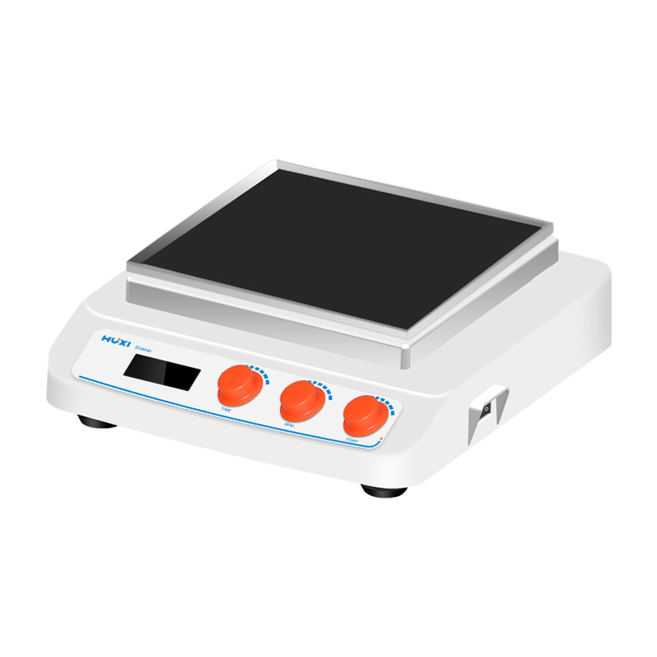

# **HT-W330GB Heating Reciprocating Shaker**

# **Shaker**

# HT-S330 **Rotary Shaker**

**Application：**

HT-W330GB Reciprocating Shaker use DC brushless motor and microcomputer control technology with various functions, which is suitable for a variety of mixing work in different fields, and is widely used for fixing various electrophoresis gels, oscillating and shaking when staining and decolorizing with Kaumas blue, fixing, staining and developing with silver nitrate staining, etc.

**Main Features：**

* Smooth rotation with low noise and resistance to wear and tear;
* Compact and simple shape structure and small footprint;
* Wide voltage design to meet the needs of different regions;
* Continuous adjustable speed up to 500rpm;
* Different types of fixtures are available to meet different experimental needs;
* Any setting time within the range of 0~99h59min, and the time controller can automatically alarm to realize unmanned operation;
* The main unit is included in the standard equipment, other accessories can be purchased separately.

**Technical Parameters：**

|  |  |
| --- | --- |
| Model | HT-W330GB |
| Item No | 1024020001 |
| Shaking mode | Reciprocating |
| Heating power | 35/185 |
| Amplitude | 8mm |
| Max load | 7.5kg |
| Motor type | DC Brushless motor |
| Input power | 35W |
| Output power | 25W |
| Speed range | 60~400rpm (optional up to 500) |
| Speed display | LCD |
| Timer function | yes |
| Timer set range | 0~99h59min |
| Power Supply | 100~240V,50/60HZ |
| NW | 7kg |
| Allowable ambient temperature | 5~40℃ |
| Allowable ambient humidity | 80% |
| Dimension（L*W*H）mm | 330*370*130 |
| Shell class | IP21 |
| Data | RS232 optional |
| Temperature set | RT+5～75℃ |
| Temperature resolution | 0.1℃ |