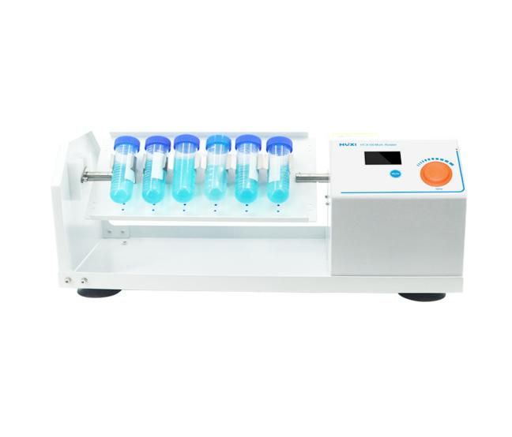

# **HT-X100 Rotary Shaker**

**Application：**

HT-X100 use DC motor and microcomputer control technology. The unique knob operation mode is simple and easy to use. By changing different trays, it can mix all kinds of commonly used test tubes. Suitable for fields such as biotechnology, microbiology and medical analysis.  
**Main Features：**

* LCD real-time display timing time and speed value;
* Knob operation mode, easy to use;
* The time can be set arbitrarily within the range of 1min-9999min, and a prompt sound will be automatically issued after the operation is completed;
* A variety of trays are available for a wide range of uses;
* DC brushless drive, accurate speed, maintenance-free.

**Technical Parameters：**

|  |  |
| --- | --- |
| Model | HT-X100 |
| Item No | 1001008002 |
| Speed Range(rpm) | 5-200 |
| Speed Display | LCD |
| Time Set(min) | 1-9999 |
| Speed countdown settings | 1-300s |
| Max Load | 6kg |
| Input Power | 25w |
| Exterior Dimension | 485*200*220mm |
| Allowable ambient temperature | 5~40℃ |
| Allowable ambient humidity | 80% |
| Weight(kg) | 7.0 |
| Motor Protection | Display failure, automatic stop |
| Safety protection | Display failure, automatic stop |
| Weight Kg | 5.5 |
| Allowable ambient temperature °C | 5-40 |
| Allowable relative humidity% | 80 |