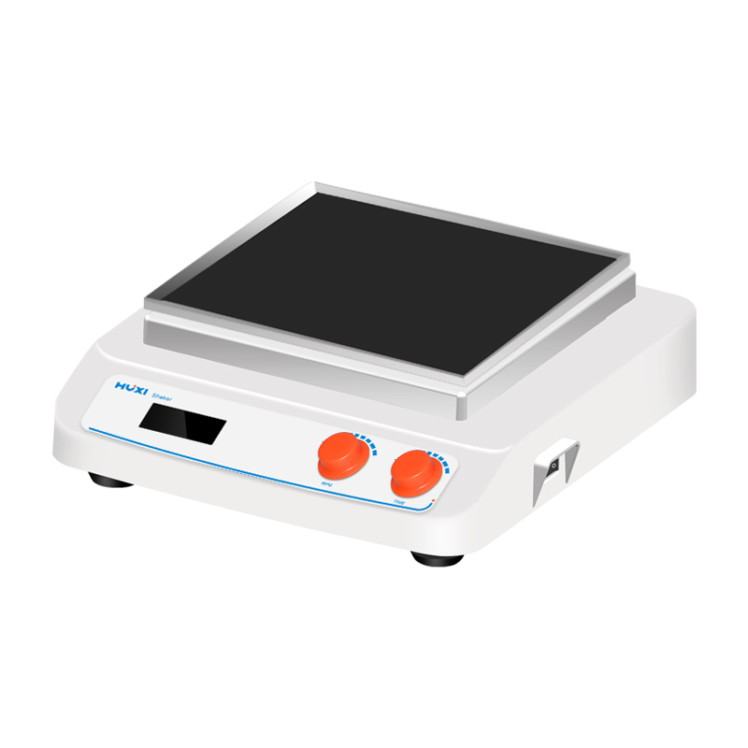

# **HT-X330 Orbital Shaker**

# **Shaker**

# HT-S330 **Rotary Shaker**

**Application：**

HT-X330 new generation of multifunctional table shaker adopts DC brushless motor and microcomputer control technology. The unique knob is easy to operate. By changing different trays, it can mix and cultivate all kinds of commonly used beakers, petri dishes, and flasks. It is suitable for the fields of biotechnology, microbiology and medical analysis, coloring or decoloring of colloids and combinatorial chemistry.

**Main Features：**

* Large-screen LCD displays timing time, rotation speed, and temperature value;
* Locked operation mode to prevent misoperation;
* Driven by brushless DC motor, low noise, accurate speed, long service life and maintenance-free;
* A variety of trays, cradles and fixtures are available for a wide range of needs;
* The replacement of accessories is convenient, which greatly improves the work efficiency;
* Soft start, uniform acceleration, effectively avoid sample splash;
* Optional RS232 interface, connected to the computer through the RS232 interface, can realize the setting of the instrument parameters on the computer and the real-time display of the working curve;

**Technical Parameters：**

|  |  |
| --- | --- |
| Model | HT-X330 |
| Item No | 1024011001 |
| Shaking mode | Orbital |
| Heating power | / |
| Amplitude | 4mm |
| Max load | 7.5kg |
| Motor type | DC Brushless motor |
| Input power | 35W |
| Output power | 25W |
| Speed range | 60~500rpm |
| Speed display | LCD |
| Time Set display | LCD |
| Timer set range | 0~99h59min |
| Power Supply | 100~240V,50/60HZ |
| NW | 8.5kg |
| Allowable ambient temperature | 5~40℃ |
| Allowable ambient humidity | 80% |
| Dimension（L*W*H）mm | 330*370*130 |
| Shell class | IP21 |
| Data | RS232 optional |