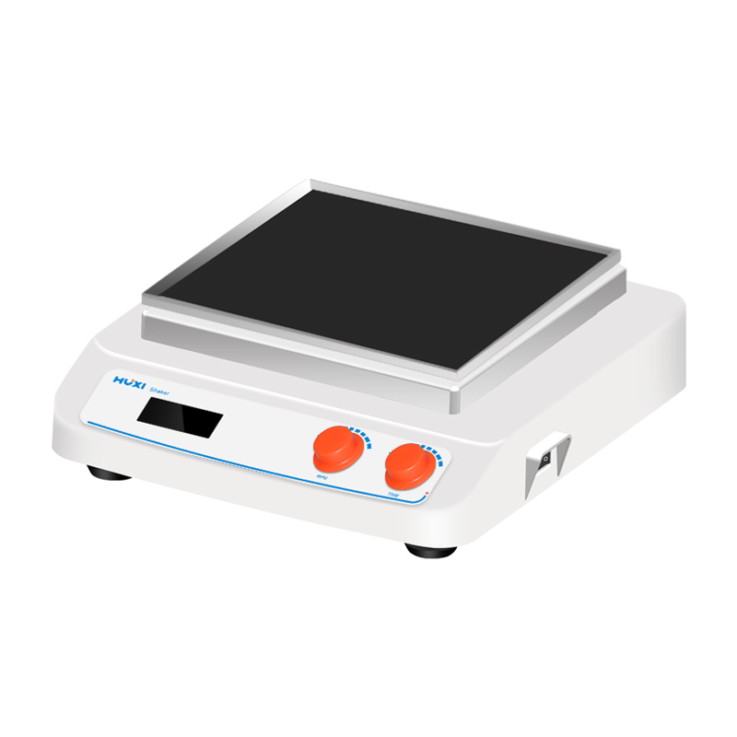

# **HT-X330F Orbital Shaker**

# **Shaker**

# HT-S330 **Rotary Shaker**

**Application：**

The HT-X330F new generation multi-functional benchtop shaker with DC brushless motor and microcomputer control technology and unique knob operation mode is simple and easy to use. By changing different trays, it is able to mix and incubate all kinds of commonly used flasks,petri dishes and beakers. It is suitable for biotechnology, microbiology and medical analysis, colloid coloring or decolorization and combinatorial chemistry.

**Main Features：**

* Large LCD display of timing time, speed and temperature values with easy-to-understand operating interface;
* Locked operation mode to prevent misoperation;
* DC brushless motor drive, low noise, accurate speed, long service life and maintenance-free;
* A variety of trays, shakers and clamps are available for a wide range of needs;
* Easy accessory replacement, greatly improving working efficiency;
* Soft start, uniform acceleration, effectively avoiding sample splash;
* Optional RS232 interface, connect to computer through RS232 interface, which can realize the setting of instrument parameters and real-time display of working curve from computer side.

**Technical Parameters：**

|  |  |
| --- | --- |
| Model | HT-X330F |
| Item No | 1024014001 |
| Shaking mode | Orbital |
| Voltage(V) | 100-240 |
| Frequency | 50/60Hz |
| Amplitude（mm） | 20 |
| Shaking mode | Orbital |
| Speed range(rpm) | 50~250 |
| Speed display | LCD |
| Timer range | 0~99h59min |
| Timer display | Yes |
| Power(W) | 40 |
| Motor type | DC brushless motor |
| Input power(W) | 36 |
| Protection class | IP21 |
| Allowable ambient temperature(℃) | 5~40 |
| Allowable ambient humidity(%) | 80 |
| Instrument dimension(mm) | 325*355*130 |
| Packing dimension(mm) | 420*390*192 |
| NW(kg) | 7.5 |
| GW(kg) | 9 |