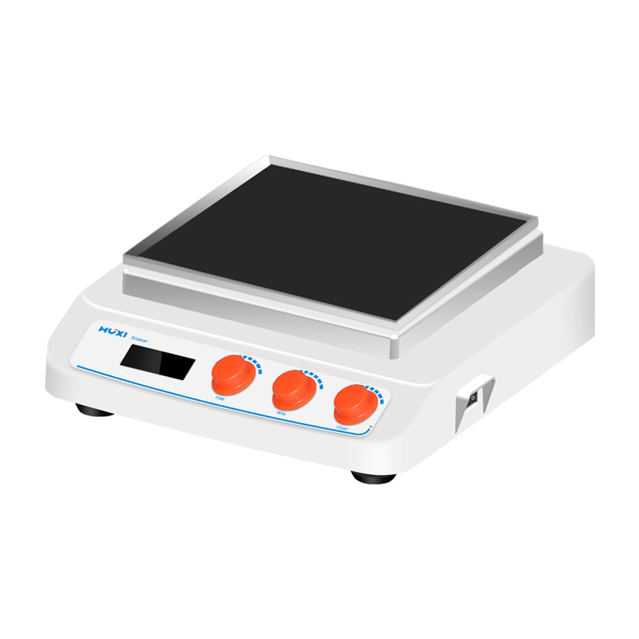

# **HT-X330GB Heating Orbital Shaker**

# **Shaker**

# HT-S330 **Rotary Shaker**

**Application：**

HT-X330GB new generation circumferential shaker adopts DC brushless motor and microcomputer control technology,unique knob operation mode is simple and easy to use. By changing different trays, it is able to mix and incubate all kinds of commonly used flasks, petri dishes and beakers. It is suitable for biotechnology, microbiology and medical analysis, coloring or decolorization of colloids and combinatorial chemistry, etc. The heating series integrates oscillation and heating functions to meet the needs of both heating and at the same time completely open experimental samples, gyratory or reciprocal oscillation, mixing and cultivation of samples.

**Main Features：**

* Large screen LCD display of timing time, speed and temperature values with easy-to-understand operating interface;
* Locked operation mode to prevent misoperation;
* DC brushless motor drive, low noise, accurate speed, long service life and maintenance-free;
* A variety of trays, shakers and clamps are available for a wide range of needs;
* Easy accessory replacement, greatly improving working efficiency;
* Soft start, uniform acceleration, effectively avoiding sample splash;
* Optional RS232 interface, which can be connected to computer through RS232 interface, and can realize the setting of instrument parameters and real-time display of working curve from computer side;
* The highest temperature of heating series can reach over 75℃, which makes up the blank of domestic oscillator that cannot operate at high temperature.

**Technical Parameters：**

|  |  |
| --- | --- |
| Model | HT-X330GB |
| Item No | 1024019001 |
| Shaking mode | Orbital |
| Heating power | 35/185 |
| Amplitude | 8mm |
| Max load | 7.5kg |
| Motor type | DC Brushless motor |
| Input power | 35W |
| Output power | 25W |
| Speed range | 60~400rpm（optional to500） |
| Speed display | LCD |
| Timer function | yes |
| Timer set range | 0~99h59min |
| Power Supply | 100~240V,50/60HZ |
| NW | 7kg |
| Allowable ambient temperature | 5~40℃ |
| Allowable ambient humidity | 80% |
| Dimension（L*W*H）mm | 330*370*130 |
| Shell class | IP21 |
| Data | RS232 optional |
| Temperature set | RT+5～75℃ |
| Temperature resolution | 0.1℃ |