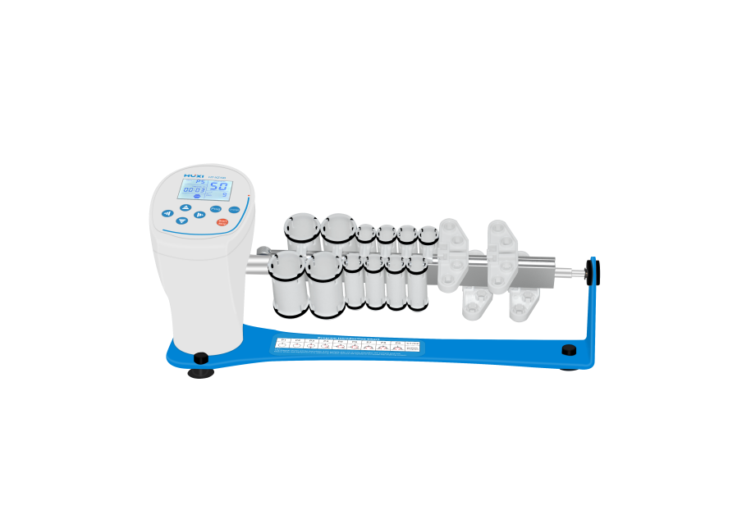

# **HT-XZ100 Rotary Shaker**

**Application：**

The HT-XZ100 uses a DC motor and microcomputer control technology to provide efficient and gentle mixing to keep biological samples in suspension. The unique knob operation mode is simple and easy to use. By changing different trays, it is able to mix all kinds of common test tubes, such as 1.5ml~50ml. Ideal for sample mixing in similar applications such as blood coagulation prevention, latex diagnostics, immunoprecipitation, etc.

**Main Features：**

● LCD real-time display of timing time and speed value;

● Knob operation mode, easy to use;

● 2 additional self-programming programs (7 bands editable for each self-programming program), 9 different self-programming programs

(rotation and vibration) to meet different needs.

● Any set time within the range of 1min-99h59m, with automatic beeping at the end of operation;

● 360°~-360° rotating vibration at any angle; adjustable vibration time and vibration speed at any angle;

● A variety of trays are available, suitable for 1.5/2.0ml, 10/15ml, 50ml and similar diameter centrifuge tubes, widely used.

● DC motor drive, precise speed and maintenance-free.

**Technical Parameters：**

|  |  |
| --- | --- |
| Model | HT-XZ100 |
| Operation mode | Orbital shaking |
| Speed(rpm) | 1-99 |
| Speed display | LCD |
| Time set | 1min-99h59m |
| Input power | 12W |
| Power Supply | DC12V |
| Standard plate | XZ100--06 |
| Instrument Size | 440x135x280mm |
| NW(kg) | 2.0 |