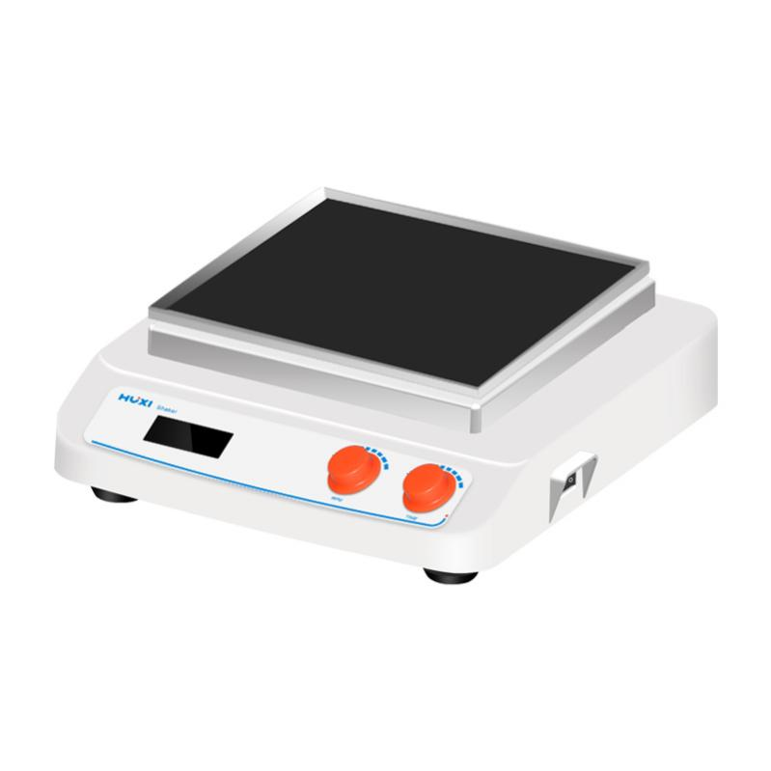

# **HTS-X330 Decolorizing Shaker**

# **Shaker**

# HT-S330 **Rotary Shaker**

**Application：**

HTS series decolourisation shaker HTS-X330 is widely used for the fixation of electrophoresis gel, the oscillation and shaking during the staining and decolourisation of komas blue, the fixation, staining and developing during the staining of silver nitrate, the developing and fixing of X-ray film in the radiographic autoradiography experiment, as well as the further processing of cellulose membrane after electrophoretic transfer, such as molecular hybridisation, the reaction of antigens and staining, and the well can be used for cell culture and cell membrane transfer, and it can be put into low temperature and constant incubator for use. It can be used in low temperature and constant temperature oven.

**Main Features：**

* Large-screen LCD display timing time, speed operation interface is simple and easy to understand;
* Locked operation mode to prevent misoperation;
* Driven by brushless DC motor, low noise, accurate speed, long service life and maintenance-free;
* Soft start, uniform acceleration, effectively avoid sample splash;
* The molded natural rubber platform can effectively prevent the corrosion of the machine from accidentally flowing out of acid-base solution, and it is very easy to clean;

**Technical Parameters：**

|  |  |
| --- | --- |
| Model | HTS-X330 |
| Item No | 1024007001 |
| Shaking mode | Orbital |
| Heating power | / |
| Amplitude | 8mm |
| Max load | 7.5kg |
| Motor type | DC Brushless motor |
| Input power | 35W |
| Output power | 25W |
| Speed range | 60~400rpm（500rpm optional） |
| Speed display | LCD |
| Time Set display | LCD |
| Timer set range | 0~99h59min |
| Power Supply | 100~240V,50/60HZ |
| NW | 8.5kg |
| Allowable ambient temperature | 5~40℃ |
| Allowable ambient humidity | 80% |
| Dimension（L*W*H）mm | 330*370*130 |
| Shell class | IP21 |
| Data | RS232 optional |