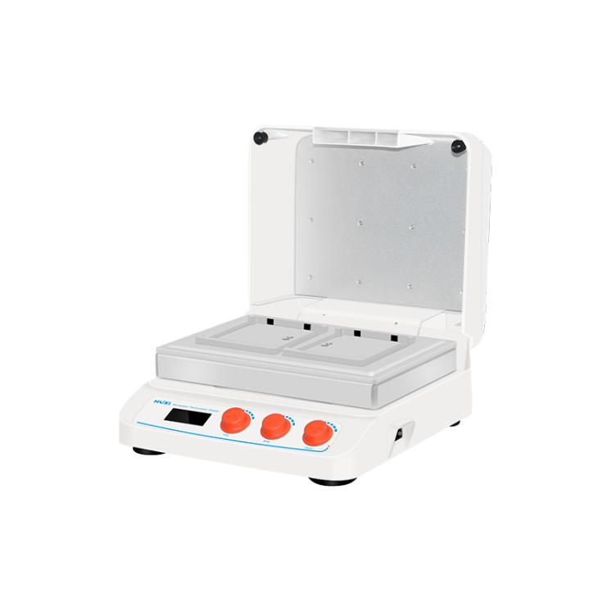

# **HW-200TG Microplate Thermostatic Shaker**

**Application：**

HW-200TG is an incubator and microplate constant temperature  shaker designed and manufactured based on microprocessing technology and PID control method. It is small size, light weight, no pollution; LCD display of temperature and time, beautiful appearance, simple operation and so on. Mainly used for ELISA plate (96-well/384-well plate), cell culture plate (24-well plate, 48-well plate, 96-well plate, etc.) and other samples to culture and incubate cells at appropriate temperature.  
**Main Features：**

● Small size, light weight, easy to operate, adopting one-key knob operation, simple and easy to use, microprocessor control temperature and time, good temperature control linearity and small fluctuation;

● With up and down heating function, so that each module can be heated evenly, using high-quality switching power supply, the whole machine is stable and reliable for long-term operation, built-in software and hardware double over-temperature protection device, safe and reliable to use;

● Multi-protection function, meets the safety standard of CE, maximum can put 2 microtiter plates or culture plates;

● LCD operation interface, real-time display of running information and setting information, convenient to observe the running status of the equipment;

● Time, speed and temperature can be controlled individually;

● The incubation time can be set arbitrarily within the range of 1-9999min, and a beep will be issued automatically when the timer is finished;

● With power failure recovery function, when the external power supply is cut off and comes back to power, the equipment can automatically resume operation according to the original set procedure.

**Technical Parameters：**

|  |  |
| --- | --- |
| Model | HW-200TG |
| Temperature Control | RT+5℃~70℃ |
| Time Set | 1min~99h59min |
| Control Accuracy | ≤ ±0.3℃ |
| Accuracy Display | ±0.1℃ |
| Speed Range | 100~1600rpm |
| Heating mode | heating film |
| Module temperature uniformity | ≤ ±0.5℃ |
| Heating Time | ≤15min（25℃ up to 70℃） |
| Sample | 2 microtiter plates or deep well plates |
| Input Power | 180W |
| Voltage | AC100-220V/50~60HZ |
| Exterior Dimension | 280*270*140mm |
| NW | 8.0kg |