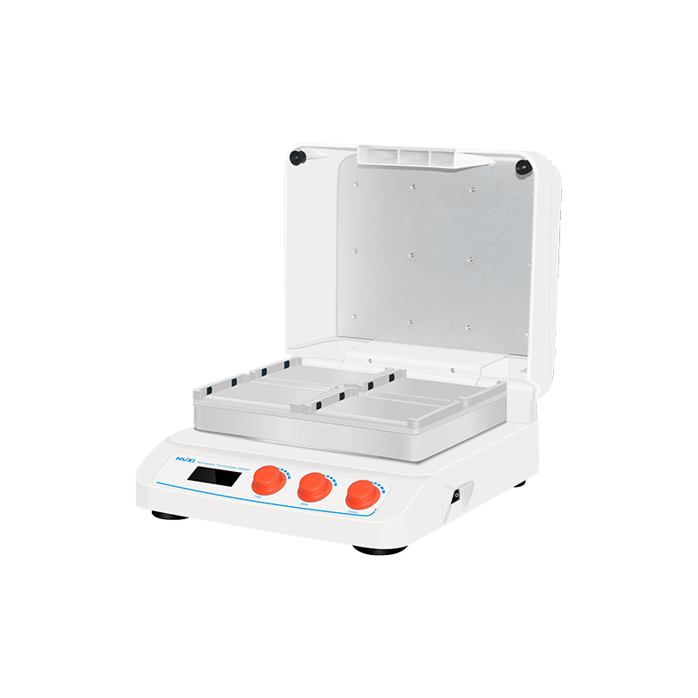

# **HW-400TG Microplate Thermostatic Shaker**

**Application：**

HW-400TG is a specialized thermostat and thermostatic oscillator that combines thin film heating and PID intelligent temperature control technology. Its PID fuzzy control technology can accurately ensure the precision of temperature control and automatically adjust the heating rate to save waiting time. The product greatly shortens the time of experimental operation and is an ideal automation tool for sample incubation, catalysis and other reaction processes.  
**Main Features：**

* Small size, light weight, easy to operate, one-key knob operation, simple and easy to use, microprocessor control of temperature and time, good temperature control linearity and small fluctuation;
* With up and down heating function, so that each module can be heated evenly, using high quality switching power supply, the whole machine is stable and reliable for long-term operation, built-in software and hardware double over-temperature protection device, safe and reliable use;
* Multi-protection function, meets the safety standard of CE, can put up to 4 microtiter plates or culture plates;
* LCD operation interface, real-time display of operating information and setting information, convenient to observe the operating status of the equipment;
* It can set the incubation time arbitrarily within the range of 1-9999min, and the beep will be issued automatically when the timer is finished;
* With the function of power failure recovery, when the external power supply is disconnected and comes back to power, the equipment can automatically resume the operation according to the original setting program.

**Technical Parameters：**

|  |  |
| --- | --- |
| Model | HW-400TG |
| Temperature Control | RT+5℃~70℃ |
| Time Set | 1min~99h59min |
| Control Accuracy | ≤ ±0.3℃ |
| Accuracy Display | ±0.1℃ |
| Speed Range | 100~1600rpm |
| Heating mode | Electric heating film |
| Module temperature uniformity | ≤ ±0.5℃ |
| Heating Time | ≤15min（25℃ up to 70℃） |
| Sample | 4 microtiter plates or deep well plates |
| Input Power | 180W |
| Voltage | AC100-220V/50~60HZ |
| Exterior Dimension | **329*359*172** |
| NW | 11.25kg |