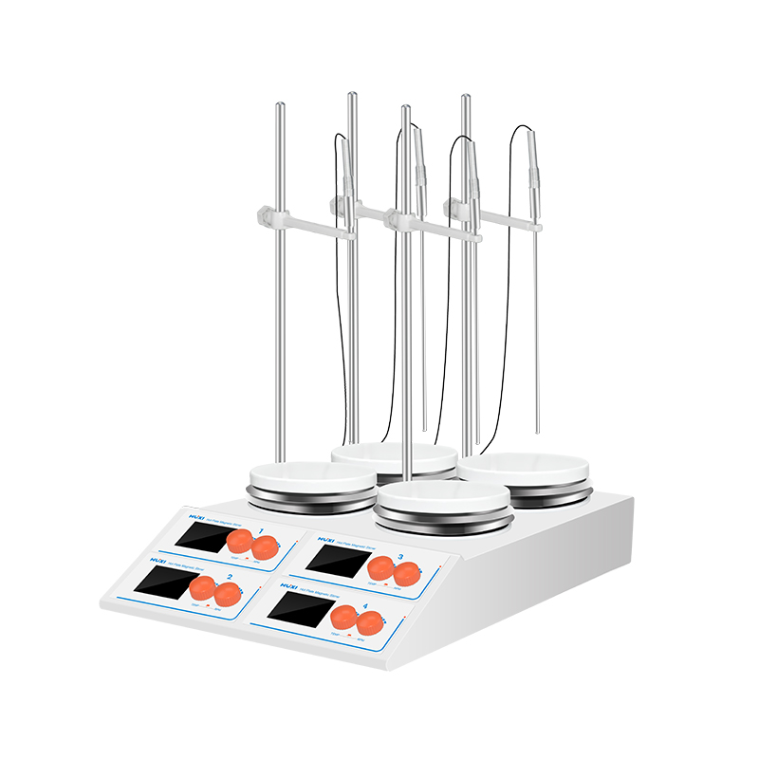

# **HMS-4SG Hotplate Multi Position Magnetic Stirrer**

**Application：**

HMS-4SG Heating Multi-station Magnetic Stirrer has a novel and beautiful design, fast heating, large heating area and even heating; it is widely used in medical, petroleum, chemical, environmental protection and other fields, and is a good helper for the experiments of Chinese Academy of Sciences, scientific research units, inspection and quarantine, and sanitary and epidemiological prevention.

**Main Features：**

* DC brushless motor, stable performance, maintenance-free;
* Low noise, long service life, low-speed smooth, high-speed strong;
* ＜30°bevelled control panel is suitable for sitting and standing view;
* PT100 temperature sensor, achieving ±1 temperature precision control;
* Rotary adjustment switch button, waterproof design, high safety factor;
* Independent control for each station, can stir up to 4 stations of different samples;
* Aluminium die-casting ceramic coated heating surface corrosion resistance, surface temperature up to 320 ℃; subject to corrosion;
* LCD digital display function, display heating temperature, stirring speed, convenient for experimental operation;
* Temperature control using PID control algorithms, self-tuning function, with high measurement accuracy, small flushing temperature;
* Shell using metal plate stamping and shaping injection moulding shell, high temperature resistance, anti-corrosion, and good insulation properties.

**Techncial Parameters：**

|  |  |
| --- | --- |
| Model | HMS-4SG |
| Power Supply | AC220 50/60 |
| Noise level(dB) | ≤27 |
| Stirring points | 4 |
| Display mode | LCD |
| Display function | Temperature & Speed |
| Control mode | Independent operation |
| Arrangement | Single Row2*2 |
| Speed Range(rpm) | 50~2000 |
| Temperature control(℃) | RT+5~160 |
| Temperature accuracy(℃) | ±1 |
| Heating plate temperature(℃) | ≤320 |
| Working plate diameter(mm) | 135 |
| Working point distance(mm) | 42~175 |
| Stirring bars(mm) | A type 9*25*4+C type 7*25*4+C type 8*45*4 |
| Single position capacity(L) | 10 |
| Single position power (W) | 10 |
| Single position heating power(W) | 350 |
| Allowable ambient temperature(℃) | 5-40 |
| Allowable ambient humidity(%) | 80 |
| Instrument Size(mm) | 539*363*121 |
| Packing dimension(mm) | 640*475*240 |
| Instrument NW(kg) | 10 |
| Packing GW(kg) | 14.3 |