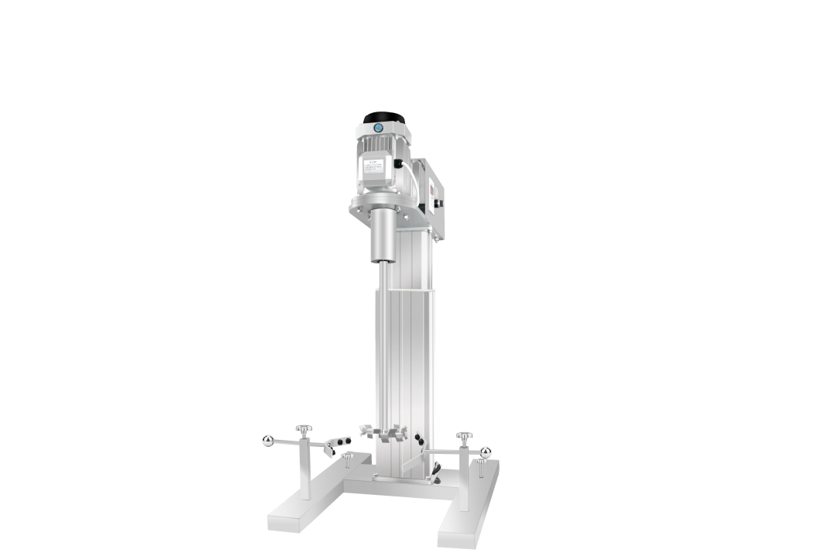

**1、Application**

**HR-1100BPF Lifting Platform Pilot Scale Disperser**

The lifting platform pilot scale disperser is suitable for dispersing, stirring and mixing pilot scale samples. It is an ideal equipment for scientific research, production development, quality control and production process simulation. Widely used in chemical, pharmaceutical, biological, cosmetic, health care products, video, etc.liquid/liquid mixing, emulsification, liquid/solid powder dispersion, homogenization, tissue cell mashing, pulping experiments.

**2、Product Features**

* The dispersing plate is made of high-quality stainless steel, with good corrosion resistance. The dispersing plate is standard, and other stirring forms can also be flexibly selected;
* The dispersing plate is connected with the dispersing shaft by hexagon screws, which is easy and flexible to disassemble and assemble;
* High-quality electric lifting platform, more stable operation, more reliable and durable;
* The output end uses a multi-machine booster mechanism. The low-speed mixer has a large operating torque output and a constant speed;
* Choose a three-phase asynchronous motor,the running temperature is stable, the noise is smaller, can run for a long time, the design is safe, and the safety is higher;
* Inverter stepless speed regulation, maintenance-free, no sparks, no dust.

1. **Technical Parameters**

|  |  |
| --- | --- |
| **Model** | **HR-1100BPF** |
| **Motor Type** | **Three-phase asynchronous motor** |
| **Voltage** | **220V/380V** |
| **Capacity** | **50L(H2O)** |
| **Power** | **1100W** |
| **Speed** | **0-3000r/min** |
| **Viscosity** | **20000cp** |
| **Lifting mode** | **Electric lifting Platform** |
| **Lifting Distance(mm）** | **400mm** |
| **Bottom Size** | **395*420mm** |
| **Spindle length** | **430mm** |
| **Spndle diameter** | **28mm** |
| **The distance between the spindle and the bracket** | **220mm** |
| **Dispersion plate off the ground** | **80mm** |
| **Exterior Dimension** | **750*620*950mm** |
| **Package Size** | **770*640*980mm** |
| **NW** | **110kg** |