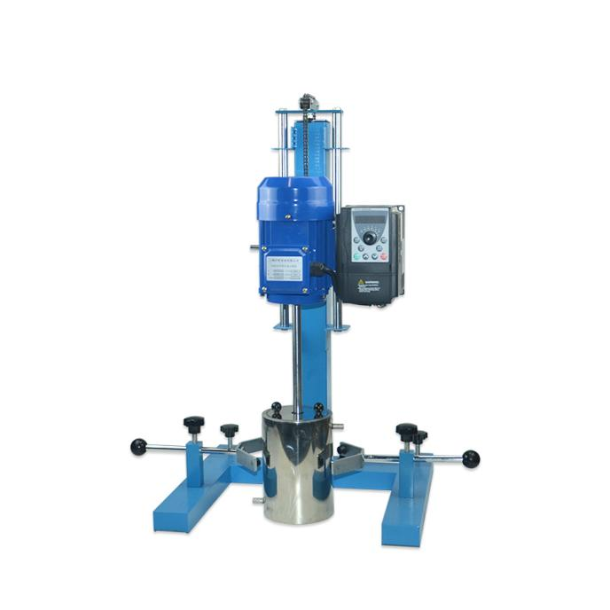

# **HR-400JFS Square tube type (frequency conversion speed regulation)** **disperser**

**Application：**

Equipped with a comfortable CN process operating system and standard-compliant safety devices, the square-tube (frequency-controlled) disperser is a durable, long-lasting, easy-to-operate and powerful high-speed disperser that easily meets a wide range of demanding dispersing and mixing experimental requirements. The scope of application includes various industries such as coatings, inks, petrochemicals, chemicals, mining, pharmaceuticals, papermaking, food, water treatment and fine chemicals. It can be applied to scientific experiments, production simulation and new product development, or industrial production of small and medium batch products.

**Main Features：**

* The dispersing plate is made of high-quality stainless steel, with good corrosion resistance; The dispersing plate is standard, and other stirring forms can also be flexibly selected;
* The dispersing plate is connected with the dispersing shaft by hexagon screws,which is easy and flexible to disassemble and assemble;
* The manual chain lifting function is selected, which is more stable, more reliable and durable;
* The output end uses a multi-machine booster mechanism. The low-speed mixer has a large operating torque output and a constant speed;
* With a brushless motor, the running temperature is stable, the noise is smaller, can run for a long time, the design is safe, and the safety is higher;
* Inverter stepless speed regulation, maintenance-free, no sparks, no dust.

**Techncial Parameters：**

|  |  |
| --- | --- |
| Model | HR-400JFS |
| Motor Type | Brush less motor |
| Braket type | Square type |
| Voltage | 220V |
| Capacity | 3L |
| Power | 400W |
| Speed Range | 0-8000r/min |
| Viscosity | 15000cp |
| Lifting moe | Chain lift |
| Lifting distance | 260mm |
| Exterior Dimension | 450*420*750mm |
| Bottom length and width | 275*330mm |
| Spindle length | 210mm |
| Spndle diameter | 16mm |
| The distance between the spindle and the bracket | 130mm |
| Dispersion plate off the ground | 30mm |