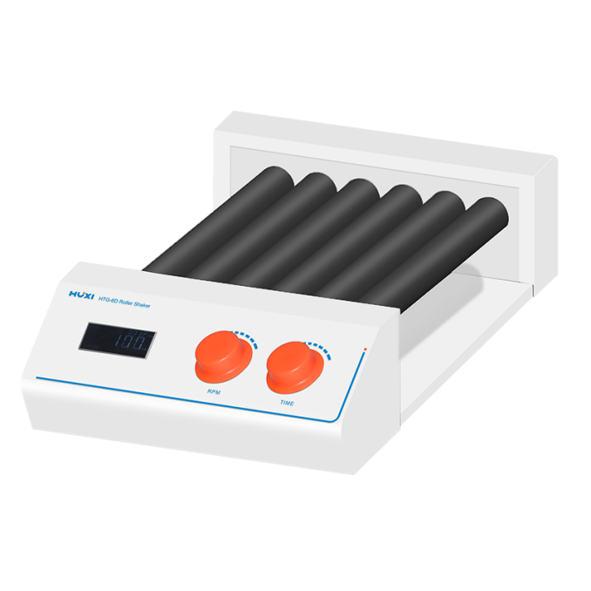

# **HTG-6D Roller Shaker**

**Application：**

HTG-6D use brushless DC motor and microcomputer control technology. The operation is simple and easy to use, and can be used for rolling, rocking and mixing of various commonly used test tubes. Roller mixers are particularly suitable for mixing blood, viscous liquids and liquid-solid suspensions. For the prevention of blood clotting, blood samples can be free of anticoagulants and will not destroy blood cells.

**Main Features：**

● LCD display shows time and speed in real time;

● The time can be set arbitrarily within the range of 0 ~ 99h/59min;

● The brushless DC motor has stable performance, adjustable speed, up to 100rpm, low noise and maintenance-free;

● There are two modes of normal rolling swing and positive and negative rolling swing;

● The rolling process is gentle, continuous and long-term operation mode, safe and reliable;

● Compatible with test tubes of different sizes, with a wide range of applications.

**Technical Parameters：**

|  |  |
| --- | --- |
| Model | HTG-6D |
| product code | 1001011001 |
| Motor type | DC |
| Operation mode | Swing and roll |
| Amplitude | 24 |
| Maximum load Kg | 4 |
| Number of rollers | 6 |
| Roller specifications (length) mm | 280 |
| Speed range rpm | 20~100 |
| Display | LCD |
| Working time setting | 1 ~ 99h59min |
| Operation mode | Timing/continuous operation |
| Power supply | 100~240V,50/60Hz |
| Power w | 15 |
| Dimensions (length x width x height) mm | 475X265X110 |
| Weight Kg | 5.5 |
| Allowable ambient temperature °C | 5-40 |
| Allowable relative humidity% | 80 |