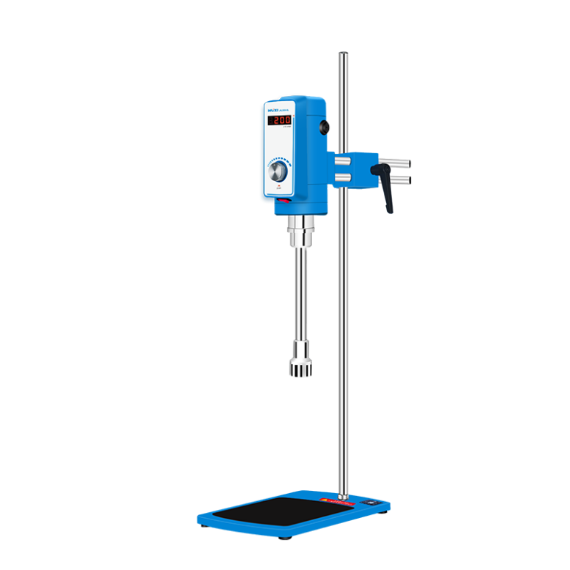

**FJ300-SL Digital Constant Speed High-speed Dispersion Homogenizer**

**Application：**

The laboratory high-speed dispersion homogenizer is driven by a compact series excited micro high-speed motor, which is suitable for further dispersion and homogenization of crushed experimental materials in liquid media in the laboratory. The machine is composed of a high-density die cast aluminum alloy as the driving host, a high-quality stainless steel refined dispersed homogeneous working head, and a speed regulating machine base. It has the characteristics of high host drive speed, high output power, convenient loading and unloading of the working head, and easy experimental operation.

**Main Features：**

* The driving motor use a series excited micro motor with high output power and compact structure, designed to be safe and reliable.
* All parts of the working head that come into contact with materials are made of high-quality stainless steel, which has good corrosion resistance.
* The working head is connected to the drive motor through a coupling, making it easy and flexible to disassemble and assemble.
* Knob speed regulation, convenient speed regulation, stable operation.

**Techncial Parameters：**

|  |  |
| --- | --- |
| Model | FJ300-SL |
| Item number | 1004040001 |
| Speed range | 2000-15000r/min |
| Processing capacity | 100-13000ml |
| display | LED |
| Speed operation | Step less speed regulation |
| Input power | 500W |
| output power | 300W |
| Use power supply | AC220V 50Hz |
| Work head configuration | φ28mm，φ36mm |
| Working methods | Continuous (long-term) |
| Head size (length x width x height) | 93*115*185mm |
| Instrument dimensions (length x width x height) | 200*315*780mm |
| Packaging dimensions (length x width x height) | 840*320*163mm |

**Packing List：**

|  |  |
| --- | --- |
| Homogenizer Host | 1 set |
| Vertical Column | 1 piece |
| Flat Base | 1 piece |
| Working Head | 2 pieces |
| Power Cord | 1 piece |
| Fixed Wrench | 1 piece |
| Inner Hexagon Spanner | 1 piece |
| Carbon Brush（Spare part） | 1 pair |
| Manual | 1 piece |