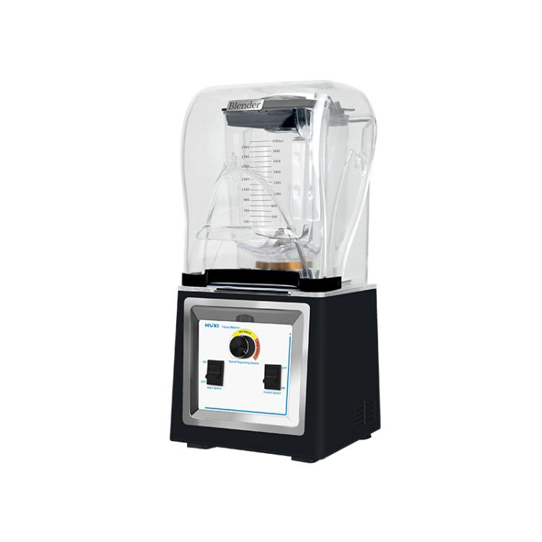

# **HX-PC2L Tissure Grinder**

**Application：**

● The HX-PC2L tissue crusher is equipped with an industrial grade powerful motor, which can rotate at a speed of up to 28000 revolutions per minute. It can quickly and efficiently grind dry or wet materials into small powder or paste, while retaining the original components. It is a multi-purpose professional high-speed machine and an essential helper for laboratory sample pretreatment.

**Main Features：**

● One machine with multiple uses (exclusively using dry/wet 2-in-1 blade heads);

● Industrial high-speed and ultra strong motor, fast and efficient, with guaranteed safety;

● The motor is made of high-quality materials, with ultra-high speed, strong and powerful performance, and a one-year warranty;

● Dual automatic protection circuit (automatic protection against over temperature/over current);

● Use stainless hardened steel blade head, the blade is incredibly strong;

● Use advanced reinforced transparent plastic steel containers, which are not fragile or damaged, heat-resistant (high-temperature vulcanization treatment, food grade silicone cover, safe and hygienic, and health guaranteed).

**Techncial Parameters：**

|  |  |
| --- | --- |
| Model | HX-PC2L |
| Item number | 1019022001 |
| Voltage | 220-240 |
| Frequency | 50 |
| Maximum overcurrent protection protection | 10A |
| power | 500W |
| Capacity | 2L |
| Speed range | 16000-28000rpm |
| Instrument dimension | 220*220*490mm |
| Packing Dimension | 285*285*545mm |
| Gross weight | 8kg |

**Packing List**

|  |  |
| --- | --- |
| Name | Qty |
| Machine host | 1piece |
| Crushing bowl | 1piece |
| Manual | 1piece |