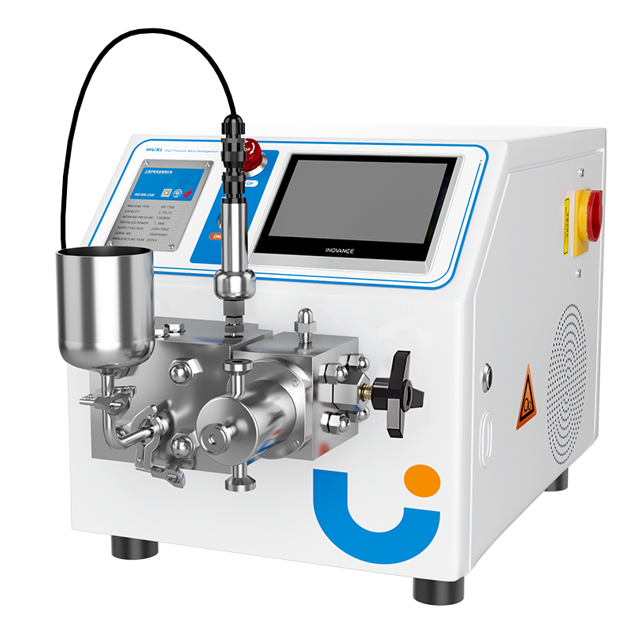

**1、Application**

**HR-1500 High Pressure Homogeniser**

High-pressure homogeniser is to make the material under the action of reciprocating movement of the plunger, transported to an adjustable size of the valve group, subject to extremely strong compression, when passing through the restriction slit, at a very high speed impact on the homogenising valve, resulting in cavity effect, impact effect and shear effect, so as to make agglomerated material uniformly dispersed. Built-in heat exchanger system, the whole 4 ℃ low-temperature environment cooling, samples throughout the high temperature stay, mainly used in: E. coli, yeast, all kinds of mammalian cells (VREO, 293, diploid).

**2、Product Features**

* The homogenising valve material can be diamond, or alloy;
* Easy observe digital display pressure gauge and electronic overpressure protection system;
* Small size, easy to place on the lab bench;
* Modular structure, easy to operate and maintain;

**3、Technical Parameter**

|  |  |
| --- | --- |
| Model | HR-1500 |
| Item No. | 1004044001 |
| Processing Samples | Escherichia coli, yeast, insect cells, etc. |
| Feed Size | ＜500μm |
| Flow | 5-15L/h |
| Design Pressure | 2000bar |
| Working Pressure | 1500bar |
| Power | 1.5kW |
| Capacity | 60ml-15L/h |
| Minimum Capacity | 60ml |
| Product Viscosity | ＜2000cP |
| Feed Temperature | ＜90℃ |
| Dispersion Level | First Class |
| Pressure Gauge | Hygienic Pressure Sensor |
| Accuracy | 1bar |
| Main Motor | Swiss ABB/Siemens 1.5kW Class 8 motor |
| Voltage and Frequency | 220V, 50Hz, Three-phase |
| Level | Hygienic Grade |
| Plunger | 1pcs |
| Internal Cooling | Fan |
| Inlet and Outlet Connection | Tri-Clamp Quick Connect |
| Max. Cleaning Temperature | ＜90℃ |
| Max. Sterilising Temperature | ＜145℃ |
| Cleaning/Sterilising Time | 30min |
| Water Consumption for Cleaning/Sterilising | 30L/h |
| External Dimension（W*H*L） | 785*450*475mm |
| Package Dimension（W*H*L） | 880*630*650mm |
| NW | 110kg |
| GW | 180kg |

|  |  |  |  |  |
| --- | --- | --- | --- | --- |
| Chiller | Standard | | | |
| Tank Volume | 2.1L | | | |
| Temperature Range | -20℃~RT | | | |
| No-load Minimum Temperature | -20℃ | | | |
| Temperature Control Accuracy | ±1℃ | | | |
| Cooling Capacity | -20℃ | -10℃ | 0℃ | 20℃ |
| 120W | 280W | 460W | 700W |
| Loop interface | Outer Diameter 10mm (Pagoda Type) | | | |
| Maximum Circulation Flow | 11L/min | | | |
| Headlift | 8M | | | |
| Pressure | 0.4bar | | | |
| Liquid Reservoir Material | SUS304 | | | |
| Refrigerants | R404A | | | |
| Shell Material | Cold plate electrostatic spraying SPCC | | | |
| Drain Valve | Yes | | | |
| Liquid Level Indicator Window | Yes | | | |
| Whole Machine Power | 420W | | | |
| Ambient Temperature | 5-35℃ | | | |
| Power Supply | 220V 50Hz | | | |
| External Dimension(L*W*H) | 445*265*535mm | | | |
| Package Dimension（W*H*L） | 500*310*600mm | | | |
| NW | 30kg | | | |
| GW | 50kg | | | |

**4、Packing List**

|  |  |  |
| --- | --- | --- |
| NO. | Name | Quantity |
| 1 | Main Unit | 1pcs |
| 2 | Chiller | 1pcs |
| 3 | Tool kit (spare dismantling spanner, spare sealing kit) | 1set |
| 4 | U disk (with 1 manual) | 1pcs |
| 5 | Certificate of Conformity | 1pcs |