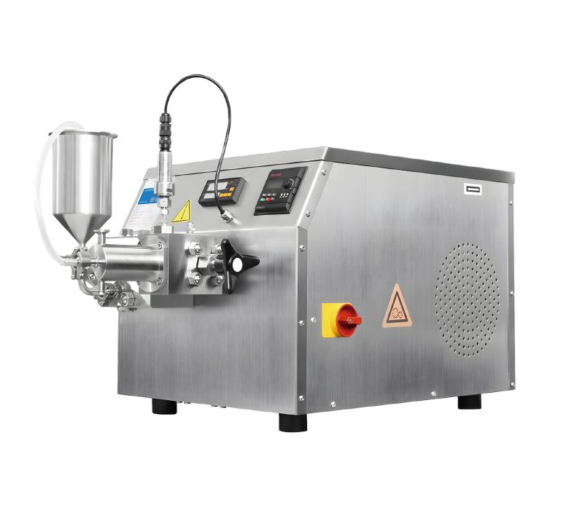

**1、Application**

**HR-BASIC30 High Pressure Homogeniser**

High-pressure homogeniser is to make the material transported to a size-adjustable valve group under the action of reciprocating movement of the plunger, subjected to extremely strong compression, and when passing through the restriction slit, it will impact on the homogenising valve at a very high speed, generating the cavity effect, the impact effect and the shear effect, so as to make the agglomerated material uniformly dispersed. Minimum handling capacity of 15ml, the highest pressure up to 2000bar, fast, convenient, 0 residue, suitable for micro-sample processing, can meet a variety of companies, colleges and universities scientific research experimental requirements.

**2、Product Features**

* The homogenising valve material can be diamond, or alloy;
* Easy observe digital display pressure gauge and electronic overpressure protection system;
* Small size, easy to place on the lab bench;
* Modular structure, easy to operate and maintain;
* Built-in temperature control module: the temperature is maintained at 5 to 10 degrees.

**3、Technical Parameter**

|  |  |
| --- | --- |
| Model | HR-BASIC30 |
| Item No. | 1004046001 |
| Processing Samples | Escherichia coli, yeast, insect cells, etc. |
| Feed Size | ＜500μm |
| Flow | 20-30L/h |
| Design Pressure | 2000bar |
| Working Pressure | 1000bar |
| Power | 2.2kW |
| Capacity | 80ml-30L/h |
| Minimum Capacity | 80ml |
| Product Viscosity | ＜2000cP |
| Feed Temperature | ＜90℃ |
| Dispersion Level | First Class |
| Pressure Gauge | Hygienic Pressure Sensor |
| Accuracy | 1bar |
| Main Motor | Swiss ABB/Siemens 2.2kW Class 8 motor |
| Voltage and Frequency | 380V, 50Hz, Three-phase |
| Level | Hygienic Grade |
| Plunger | 1pcs |
| Internal Cooling | Fan |
| Inlet and Outlet Connection | Tri-Clamp Quick Connect |
| Max. Cleaning Temperature | ＜90℃ |
| Max. Sterilising Temperature | ＜145℃ |
| Cleaning/Sterilising Time | 30min |
| Water Consumption for Cleaning/Sterilising | 30L/h |
| External Dimension（W*H*L） | 787*448*459mm |
| Weight | 170kg |

|  |  |  |  |  |
| --- | --- | --- | --- | --- |
| Chiller | Standard | | | |
| Tank Volume | 2.1L | | | |
| Temperature Range | -20℃~RT | | | |
| No-load Minimum Temperature | -20℃ | | | |
| Temperature Control Accuracy | ±1℃ | | | |
| Cooling Capacity | -20℃ | -10℃ | 0℃ | 20℃ |
| 120W | 280W | 460W | 700W |
| Loop interface | Outer Diameter 10mm (Pagoda Type) | | | |
| Maximum Circulation Flow | 11L/min | | | |
| Headlift | 8M | | | |
| Pressure | 0.4bar | | | |
| Liquid Reservoir Material | SUS304 | | | |
| Refrigerants | R404A | | | |
| Shell Material | Cold plate electrostatic spraying SPCC | | | |
| Drain Valve | Yes | | | |
| Liquid Level Indicator Window | Yes | | | |
| Whole Machine Power | 420W | | | |
| Ambient Temperature | 5-35℃ | | | |
| Power Supply | 220V 50Hz | | | |
| External Dimension(L*W*H) | 445*265*535mm | | | |
| Weight | 30kg | | | |

**4、Packing List**

|  |  |  |
| --- | --- | --- |
| No. | Name | Quantity |
| 1 | Main Unit | 1pcs |
| 2 | Chiller | 1pcs |
| 3 | Tool Kit (Spare Dismantling Spanner, Spare Sealing Kit) | 1set |
| 4 | U disk (with 1 manual) | 1pcs |
| 5 | Certificate of Conformity | 1pcs |