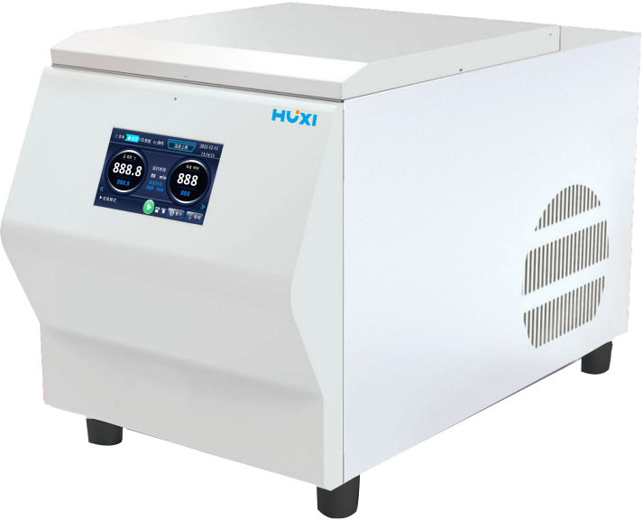

**HM-24LS Benchtop Freeze Tissuelyser (Noise Reduction Model)**

**1、Product Application**

HM-LS Series benchtop freeze Tissuelyser (Noise Reduction Model) adopt a special vertical up and down one-piece vibration mode, through the grinding beads (zirconium oxide, steel beads, glass beads, ceramic beads) of high-frequency reciprocating oscillations, impact, shear, fast to achieve the purpose of the grinding of samples with a fuller, more uniform characteristics, better sample reproducibility, and no cross-contamination.

**2、Product Features**

* High-throughput milling, which can complete the milling of 2ml*24 samples within 1 minute, saves time and effort, with low intra-batch variation, higher specific activity of extracted proteins and longer nucleic acid fragments;
* Sample tubes are fully closed during the crushing process, disposable centrifuge tubes and beads can be used, and samples are kept intact inside the tubes to avoid cross contamination between samples as well as outside contamination;
* User-friendly operation interface, built-in programme controller, can set parameters such as grinding time, vibration frequency of the rotor and so on;
* Vertical oscillation is adopted for more adequate grinding and good stability;
* Full metal body, working chamber safety lock, improve the stability of the whole machine, to ensure the safety of samples and experimental;
* During the operation of the instrument, the noise <55dB, will not interfere with other experiments or instruments;
* When low-temperature grinding environment is required, the adapter with sample can be immersed in liquid nitrogen to cool down for 1~2min, and then removed to the main unit for quick fixation to start grinding, without the need of refrigeration treatment again, saving liquid nitrogen;
* Good repeatability, set the same programme for the same tissue sample to obtain the same grinding effect, short working time and no rise in sample temperature.

**3、Technical Parameters**

|  |  |
| --- | --- |
| Model | HM-24LS |
| Item No. | 1019041001 |
| Sample Process | Simultaneous processing of 24 samples in 15s |
| Sample Volume | Standard 2ml*24 PE adapter, Optional 5ml*12 adapter, 10ml*4 adapter, 25ml*2adapter , 50ml*2 metal grinding jar |
| Feed Size | Adjustment according to adapter |
| Discharge Size | ~5μm |
| Display Mode | Touch Screen |
| Number of Grinding Platforms | ＞2 |
| Grinding Frequency | 0~70Hz |
| Grinding Time | 0s~99min(Freedom Setting ) |
| Grinding Ball Diameter | 0.1~30mm |
| Grinding Ball Material | Alloy steel, chrome steel, zirconium oxide, tungsten carbide, quartz sand, etc. |
| Acceleration | Higher speed can be reached in 2s |
| Noise Level | ＜55dB |
| Grinding Method | Vertical ball grinding(Wet grinding, dry grinding, low temperature grinding are available) |
| Freezing Range | 0~-50℃ free adjustment |
| Instrument Size (L*W*H) | 700*400*500mm |
| Weight | 50kg |

**4、Packing List**

|  |  |  |
| --- | --- | --- |
| No. | Item | Quantity |
| 1 | Main Host | 1pcs |
| 2 | Power Line | 1set |
| 3 | 2ml/5ml Grinding Tube | Optional 1 pack |
| 4 | 2ml*24 PE Adapter | 1pcs |
| 5 | 3mm、6mm Grinding Ball | 1 bottle of each |
| 6 | Instruction manual & Certificate of Conformity (with warranty card) | 1pic |