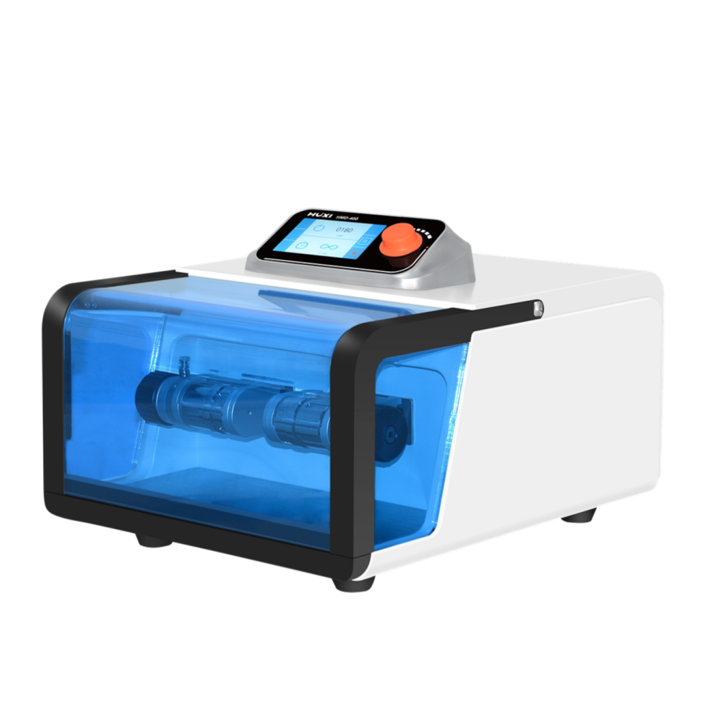

HMD-400 Multifunctional Tissuelyser

Application：
● The HMD-400 multifunctional tissuelyser is specially designed to handle fine grinding and fine grinding of hard, medium-hard and brittle samples in the laboratory. The sample range contains samples of grains, oil seeds, soil, tobacco, wood, animal feed, cheese, fruits, bones, hair, plant and animal tissues, fertilizers, electronic waste, sludge, alloys, coal, ores, chemicals, plastics, ceramics, glass, DNA extraction, etc.

Main Features：
● Adopt large screen touch screen operation display, easy to understand operation and setting;
● Equipped with memory function, which can store many kinds of operation procedures;
● Intelligent control, grinding time can be controlled, time and speed can also be set and displayed;
● High reproducibility of grinding results;
● fast grinding and homogenization with short grinding time, which can be used for XRF analysis with high processing capacity of rapid sample preparation;
● dual jar grinding and the availability of high throughput grinding for biological samples;
● For most materials it takes only a few tens of seconds to grind, mix and homogenize the sample.

Techncial Parameters：
Model | HMD-400
Features | Crushing ,grinding ,mixing and homogenizing
Sample type | Hard,soft,brittle,elastic,hydrated,fibrous
Put in sample size(mm) | 40
Out sample size(μm) | about 5-10
Batch capacity(ml) | ≤2x50
Grinding time(min) | 1-3
Grinding mode | Dry grinding, wet grinding, low temperature grinding, high throughput grinding
Grinding tank qty | 2
Grinding tank category | Screw-cap tanks (various material options)
Shaking speed(r/min) | 60-2100
Frequency(Hz) | 1-35
Crushing time(min) | 0-9999min
Power(W) | 250
WxHxD(mm) | 395*475*300
Net weight(kg) | about28

